Ethel Mary (Siears) Scharwath
November 14, 1916 – June 18, 2005

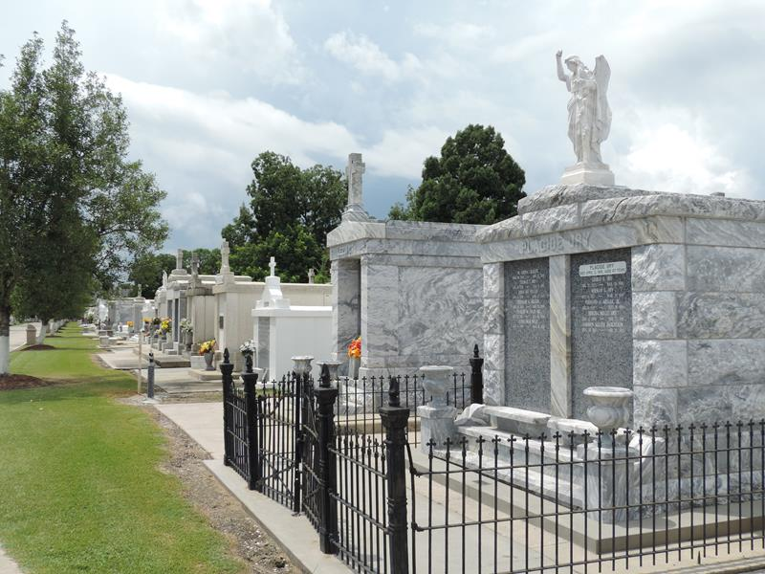

Ethel Mary Siears Scharwath On Saturday, June 18, 2005 At 7:43 P.M.
Beloved Wife Of The Late Herbert Scharwath. Mother Of Frank And George Scharwath, Faith S. Coneglio, Ethel Scharwath, Joy S. Monica, Aleta (Cookie) Scharwath And The Late Frank, Jr. And David Philip Scharwath.
Daughter Of The Late Frank George And Stella Zimmer Siears. Sister Of Gertrude Duhe, Hilda Kilburn And The Late Evelyn Siears, Frank Siears And Joseph Bell Thompson, Jr. Also Survived By 18 Grandchildren, 28 Great Grandchildren And 4 Great Great Grandchildren. Age 88. A Native Of Lutcher, La And A Resident Of Garyville, La For The Past 60 Years.
Relatives And Friends Of The Family, Also Trinity Hospice, Ladies Altar Society, Msgr. Eyraud Kaycee Auxillary, Vfw Ladies Auxilliary 8167, The Garyville Fire Dept., Catholic Daughters And Members Of Homemakers Of America Are Invited To Attend Services. Visitation At St. Hubert Catholic Church, 176 Anthony F. Monica St., Garyville, La On Wednesday, June 22, 2005 From 9:00 A.M. Until 11:00 A.M. Followed By Religious Services At The Church At 11:00 A.M. Burial In St. Peter Cemetery, Reserve, La.
Arrangements By Millet-Guidry Funeral Home, Laplace, La.

Times Picayune, New Orleans, Louisiana
June 21, 2005

