Adam J. Schexnayder Jr.
November 25, 1921 – April 19, 2012

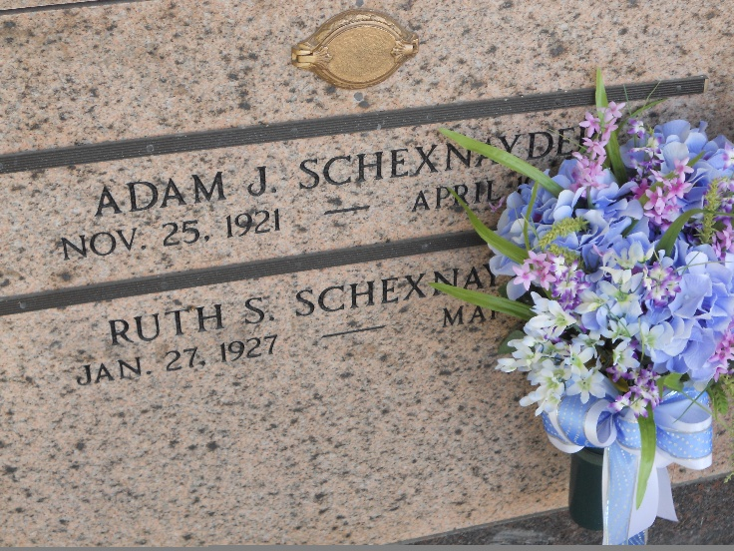
Photo by Team T-Lo

Adam (Schex) J. Schexnayder, Jr. passed away on Thursday, April 19, 2012.
Beloved husband of Ruth Satterlee Schexnayder for 64 loving years. Father of Suzanne Schexnayder, Connie Rutherford and Jeanette Brady (Curtis). Grandfather of Nicole Schexnayder, Ralph Rutherford (Michelle), Brandon Marks, Amanda Gallo (Anthony), Travis Marks (Beth), Sarah Brady and 9 great-grandchildren. Son of the late of the late Adam and Clothilde Schexnayder. Brother of the late Virginia and Rita Schexnayder. Age 90. A native and resident of LaPlace, LA.
Relatives and friends are invited to attend services. Visitation at St. Joan of Arc Catholic Church, 529 W. 5th St., LaPlace, LA on Saturday, April 21, 2012 from 10:00am to 1:00pm, followed by Mass at 1:00pm. Burial in St. Peter Cemetery, Reserve, LA.
The family would like to express a special thanks to the staff of Royal/Twin Oaks Rehab and Harmony Hospice.
Arrangements by Millet-Guidry Funeral Home, LaPlace, LA.

Times Picayune, New Orleans, Louisiana
April 19-20, 2012

