Aurelie (Bourgeois) Schexnayder
May 29, 1875 – November 16, 1970

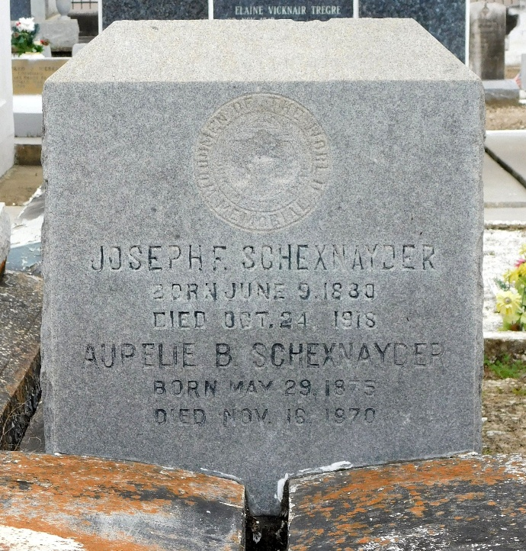
Photo by Mary Agnes Hammett

Mrs. Aurelie Bourgeois Schexnayder on Monday, November 16, 1970, at 4:50 o'clock p.m., wife of the late Florian Schexnayder; mother of Mrs. Norma Piper of Baton Rouge, La, and Harris J. Schexnayder Sr. of Lutcher, La; sister of Mrs. Leus Landry, Mrs. William R. Ford and Achille Bourgeois, all of Lutcher, La, and of the late Mrs. Aline Vicknair, Mrs. Maria Polizzoto, Anicet, Aloysius, Leonce, Numa and Septime Bourgeois, also survived by 8 grandchildren and 12 great grandchildren; age 95 years; a resident of Lutcher, La.
Relatives and friends of the family are invited to attend the funeral. Services from the Alexander Funeral Home, Lutcher, La, on Wednesday, November 18, 1970 at 9:45 o'clock a.m. Religious services at St Joseph Church, Paulina, La, at 10 o'clock a.m. Interment in St Peter's Cemetery, Reserve, La.
The Times-Picayune, New Orleans, Louisiana
17 Nov 1970, p 18

