Leslie Jude Schexnayder
May 29, 1949 – December 25, 2023

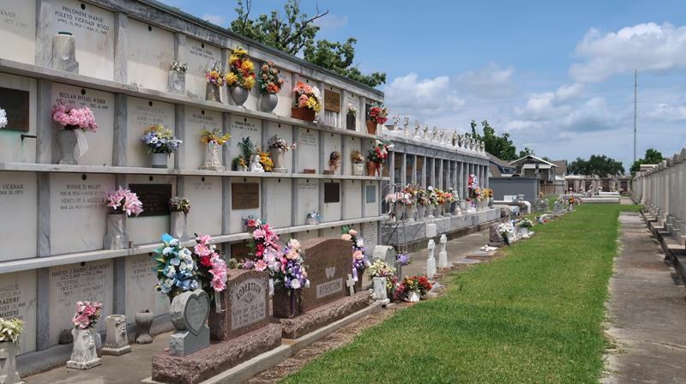

Leslie Jude Schexnayder, known affectionately as "Les" or "BC," passed away on December 25th, 2023 at the age of 74 in Thibodaux, LA. He was born on May 29th, 1949 in New Orleans, LA. Les was a loving and supportive husband to Claudia Knight Schexnayder of Lutcher, LA, and a devoted father to his son Brian (Sarah) of Carlsbad, CA. He took great pride in his role as a grandfather to Hannah and Jake Schexnayder.
Les was preceded in death by his parents, Leonard and Doris Sorapuru Schexnayder, his brother Llewellyn Schexnayder, and his in-laws Charles and Rose Knight.
Les leaves to cherish their memories his brothers and sisters: Rhonda Perrin (Stanley) of Luling, LA, Reed (Lisa) of Destrehan, LA, Michelle, Leonard Jr., and Darnell of Lucy, LA, Todd (Valerie) of Baton Rouge, LA, Patrice of Hahnville, LA, Valerie Richardson (Willie) of Kennesaw, GA. Les also leaves behind a host of nieces, nephews, an uncle, aunts, and was a proud godfather to Ryan Cambre, Michelle Gautier, Michael Boudoin, Jr, Leonard Sorapuru III and Keith Schexnayder.
Les was a charitable and hardworking individual who had a passion for helping others. He had a great sense of humor and was known for his competitive spirit when it came to football and bowling. Les enjoyed spending his free time fishing, golfing, and cooking. He had a deep love for his family and enjoyed creating lasting memories with them.
Les served as a Corporal in the U.S. Marine Corps from 1968 to 1970. After his military service, he embarked on a successful career that spanned over several decades. He worked for 6 years at IE DuPont and later spent 30 years at Marathon Oil as a shift supervisor. Les also had the opportunity to work on the Marathon Turnarounds in various locations, including Detroit, MI, Canton, OH, and Malabo, Africa.
In addition to his corporate career, Les was the proud owner of Hi-Tech Services, Inc. for over 10 years. Les worshiped at St. John the Baptist Catholic Church in Edgard, LA. His faith was an important aspect of his life and provided him with strength and guidance.
A ceremony to celebrate Les' life will be held at St. John the Baptist Catholic Church in Edgard on December 30th, 2023. A visitation for family and friends will be held from 8:00 a.m. to 10:00 a.m. on Saturday, December 30, 2023 at Saint John the Baptist Catholic Church, 2361 Hwy 18, Edgard, LA with a Mass of Christian Burial at 10 am. Interment will be at St. Peter Cemetery, 1550 Highway 44, Reserve, LA. Rev. Paul Clark, Celebrant. Lake Lawn Funeral Home is in charge of the arrangements.
In lieu of flowers, the family kindly requests that contributions be made to St. Jude Children's Hospital and the American Red Cross, organizations that held a special place in Les' heart.
Leslie Jude Schexnayder will be dearly missed by his family, friends, and all those whose lives he touched. His charitable spirit, hard work ethic, and fun-loving nature will be remembered and cherished forever.

Lake Lawn Metairie Funeral Home & Cemeteries, Louisiana

