Dorothy Ann (Scharwarth) Schexnayder
June 18, 1937 – November 25, 2013

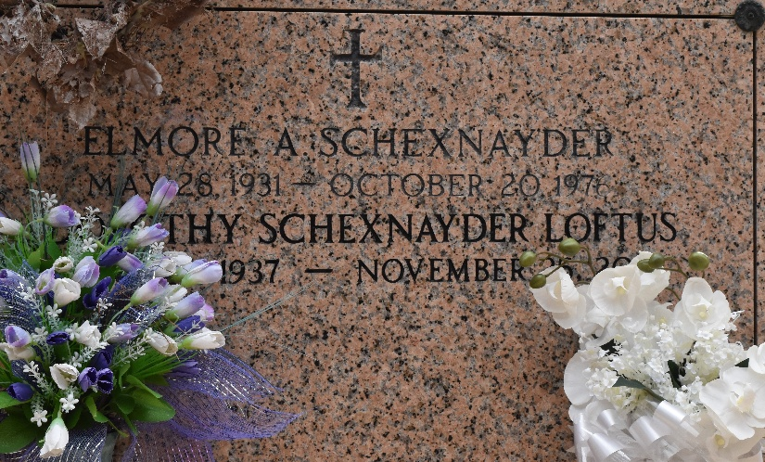

Dorothy Scharwarth Schexnayder Loftus died on Monday November 25, 2013.

Beloved wife of Peter Loftus and by first marriage of the late Elmore Schexnayder. Mother of Karen Kopfinger (Philip), Vicky Sisk (David), Randy Schexnayder (Shirley), Brian Schexnayder (Tammy) and Carla Williamson (Johnny). Also survived by 18 grandchildren and 19 great-grandchildren.

Daughter of the late Ralph Scharwarth and Adele Scharwarth Robison. Sister of Barbara Cox, Robert Scharwarth and the late Kenneth Scharwarth, Carolyn Scharwarth, Vivian Shelton and Brenda Brumfield.
Age 76. A native and resident of LaPlace, LA.
TheNewOrleansAdvocate.com
Nov. 26 to Nov. 27, 2013

