Mildred (Landry) Schexnayder
January 31, 1931 – July 26, 2015

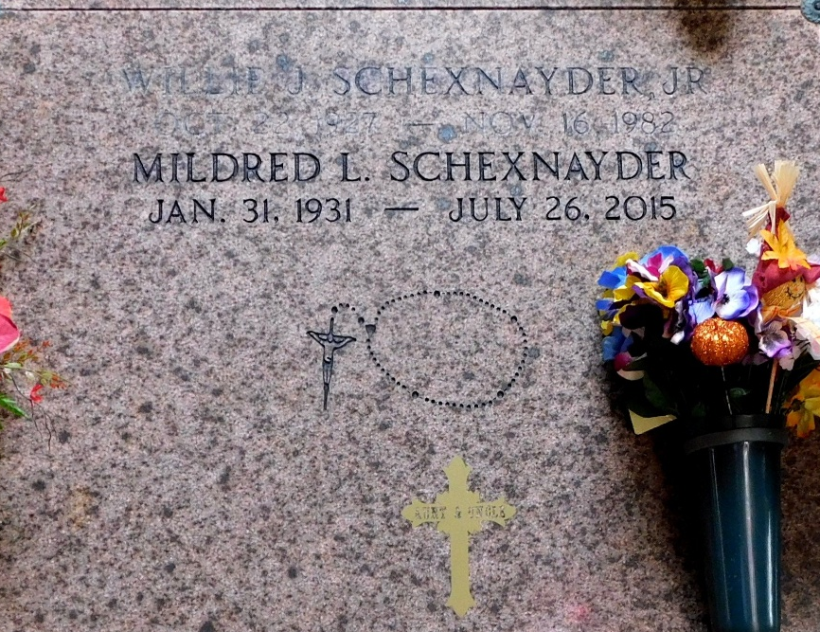
Photo by Mary Agnes Hammett

Mildred Landry Schexnayder, age 84, a native of Norco and a resident of Garyville was born on January 31, 1931 and passed away on Sunday, July 26, 2015. She is survived by a sister, Lelia Tassin of LaPlace. She is preceded in death by her husband, Willie Schexnayder, Jr., parents, Louis and Lelia Miller Landry, brother, Raleigh Landry; sisters: Emma LeJune, Eula Vicknair, Gladys Weber, Barbara LaBruzzo, Ida Kay Ougal, Juliette Deshotel, Mary Louise Berteau, and Rose Mary Wilkinson.
Visitation will be on Wednesday, July 29, 2015 from 9:00 a.m. until 10:45 a.m. at St. Hubert Catholic Church in Garyville followed by a Mass of Christian Burial at 11:00 a.m. Burial will be in St. Peter Catholic Church Cemetery.
Special thanks to St. Catherine's Hospice, Shawna Rawls, Darlene Johnson, Trina Pellissier, Cindy Champagne, and Lisa Gutierrez for their care and support.
ROSE LYNN FUNERAL SERVICES, 1870 CABANOSE AVE., LUTCHER, LA is in charge of the arrangements.

The Advocate, Baton Rouge, Louisiana
July 27-29, 2015

