Ruth (Satterlee) Schexnayder
January 27, 1927 – May 1, 2014

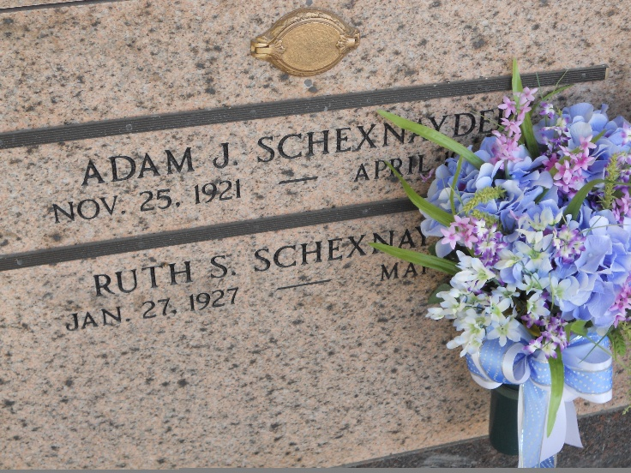
Photo by Team T-Lo

Ruth 'Sis' Satterlee Schexnayder died on Thursday May 1, 2014.
Beloved wife of the late Adam 'Schex' Schexnayder Jr. Mother of Suzanne Schexnayder, Connie Rutherford and Jeanette Brady (Curtis). Grandmother of Nicole DeBarbieris (Jason), Ralph Rutherford (Michelle), Brandon Marks, Amanda Gallo (Chad), Travis Marks (Beth), Sarah Brady and 9 great-grand-children. Cherished friends, Sandy Phillips and Nichelle Roberson. Also her faithful dog Holly.
Daughter of the late Marion and Blanche Delhommer Satterlee. Sister of the late Marion Jr., Herbert and Roland Satterlee. Age 87. A native and resident of LaPlace, LA.
Relatives and friends are invited to attend services. Visitation at St. Joan of Arc Catholic Church, 529 W. 5th St., LaPlace, LA on Monday May 5, 2014 from 10:00 a.m. to 11:45 a.m., followed by Mass at 112:00 noon. Burial in St. Peter Cemetery, Reserve, LA.
The family would like to express thanks to the staff of Twin Oaks.
Arrangements by Millet-Guidry Funeral Home, LaPlace, LA.

Times Picayune, New Orleans, Louisiana
April 19-20, 2012

