Suzanne Marie Schexnayder
April 9, 1949 - May 4, 2021

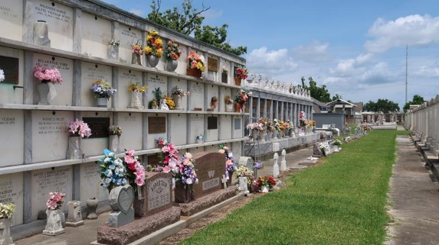
Photo by Mary Agnes Hammett

Suzanne Marie Schexnayder, a native and resident of LaPlace, Louisiana, passed away on May 4, 2021 at the age of 72.
Suzanne started her career as a staff nurse at Ochsner in 1970 but excelled in management. She moved on to become the Director of Purchasing at Ochsner. She then went on to work in purchasing positions at Cardinal Health in Houston, TX and FMOL Health System in Baton Rouge, LA. She loved spending time with her family and friends. She enjoyed traveling. She also appreciated researching and visiting good restaurants.
Suzanne is survived by her daughter, Nicole Schexnayder Debarbieris (Jason); her grandchildren, Morgana Lee, Madeleine Debarbieris, and Matthew Debarbieris; her sisters, Connie Schexnayder Rutherford and Jeanette Schexnayder Brady (Curtis); her nieces and nephews, Ralph Rutherford, Brandon Marks, Amanda M. Duhe (Stevie), Travis Marks (Beth), and Sarah Brady; and her chosen family member, Sandy Phillips; and numerous great-nieces and great-nephews. She is also survived by many close friends.
She was proceeded by her parents, Adam J. Schexnayder and Ruth Satterlee Schexnayder.
A visitation will be held at St. Joan of Arc in Laplace, LA on Friday, May 7, 2021 from 11:30 am until funeral time. A Mass of Christian Burial will be held in the church at 1:30 pm. Interment will follow at St. Peter's Cemetery in Reserve, LA. Rose Lynn Funeral Home has been entrusted in handling her arrangements.

The Advocate, Baton Rouge, Louisiana
May 6-8, 2021

