Virginia Mary Schexnayder
August 26, 1920 – November 5, 2010

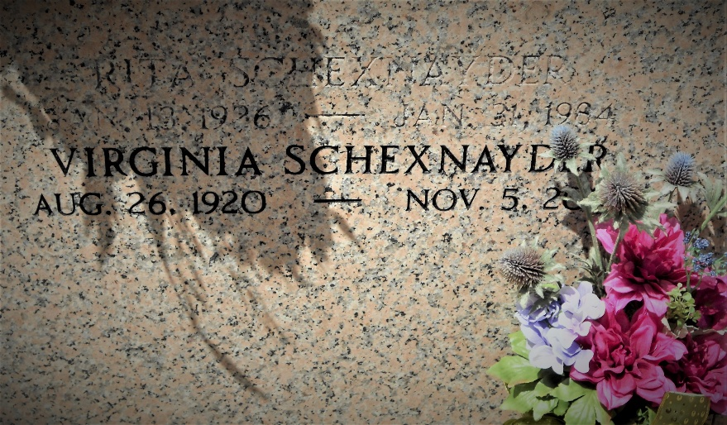
Photo by Team T-Lo

Virginia "Noon" "Nanain" Mary Schexnayder passed away at age 90 on Friday, November 05, 2010. She was a resident of LaPlace.
She was preceded in death by parents, Adam J. and Clothilde Triche Schexnayder and sister, Rita P. Schexnayder.
She is survived by her beloved brother, Adam Schexnayder, sister-in-law, Ruth Satterlee Schexnayder, nieces, Suzanne Schexnayder, Connie S. Rutherford, Jeanette Brady (Curtis), great nephews Ralph Rutherford, Brandon Marks, Travis Marks, great nieces Nicole Schexnayder, Amanda Gallo, Sarah Brady. and several great-great nieces and 1 great-great nephew.
Relatives and friends of the family are invited to attend services. Visitation at Millet-Guidry Funeral Home, 2806 W. Airline Hwy., LaPlace, LA, on Saturday, November 6, 2010 from 9:00 am until 11:00 am. Followed by a Mass in the Funeral Home Chapel at 11:00 am. Interment will immediately follow in St. Peter Cemetery, Reserve, LA.
The family would like to express thanks to her long time physician, Dr. Colin Bailey and the staff of Twin Oaks Nursing Home and Harmony Hospice for their love and care toward the end of Virginia's life.

Times Picayune, New Orleans, Louisiana
November 6, 2010

