Mary Madeline (Fischer) Schloesser
January 1869 – April 15, 1943

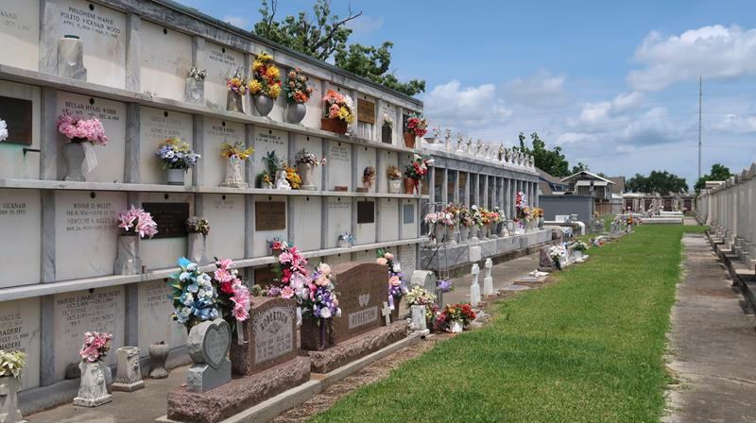
Photo by Mary Agnes Hammett

SCHLOESSER-At Frenier, La, on Thursday, April 15, 1943, at 9:10 o'clock p.m., MARY MADELINE FISCHER, beloved wife of Martin Schloesser, mother of Caroline Schloesser of Frenier, La, and foster mother of Mrs. Ethel Bacas of Buras, La, and Claude Moore; age 73 years.
Funeral took place at St Peter's church, Reserve, La, on Saturday morning, April 17, 1943 at 9 o'clock mass from the Jules Millet Funeral Home, Reserve, La. Interment in St Peter cemetery, Reserve, La.

Times-Picayune, New Orleans, Louisiana
April 18, 1943, p. 8
**

New Orleans Marriage records

Martin Schloesser, age 30, a native of New Orleans and son of Mathias Schloesser and Helena Marin, married St. Marys Church on 26 Sep 1891 to Mary M. Fischer, age 22, a native of New Orleans and daughter of John Fischer and Frances Schindler.

