Helen Jane (Jenkins) Schnyder
September 7, 1935 – August 15, 2023

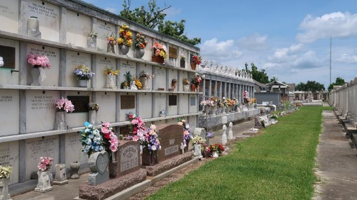

Helen Jane (Jenkins) Schnyder transitioned from this life to her eternal resting place on August 15, 2023. She was born on September 7, 1935, one of ten children to the late Fred and Mary (Montgomery) Jenkins in Wood-stock, Mississippi. Helen graduated in 1952 from Brumfield High School in Natchez, Mississippi.
In 1953 she married Reynold J. Schnyder, Sr. and was blessed with 15 children. In addition, she raised three of her grandchildren. Helen was a loving wife, mother, grandmother and aunt. She loved interior decorating, cooking and gardening. She was known to everyone as Ms. Bee, Queen Bee or Ms. Bumble Bee.
Helen was preceded in death by her parents Fred and Mary Jenkins, husband Reynold J. Schnyder, daughter, Cutuchea Schnyder; grandsons Stephen Schnyder and Ted Mitchell; Great-grandson Koi Taylor, Jr.; Stepsons Reynold, Jr., John and Harold Schnyder; Sisters Fanny Hollands, Beatrice Schanult, Mamie Fisher and brother Henry Jenkins.
She will truly be missed by her daughters Yolanda (Lynell) McCollough of Birmingham, AL, Sedgie Gomes of Houston, TX, Tangee (Bruce, Sr.) Jackson of Mansura, LA, Ingrid Schnyder of Reserve, LA., Tiffany (Conde) Monier of New Orleans, LA., Yvette (Alvin) Scioneaux of Garyville, LA., Victoria (Andrew, Sr.) Taylor of Laplace, LA; Sons Kevin (Terri) Schnyder, Kirk Schnyder of Reserve, LA. Keith Schnyder and Remy (Jacqueline) Schnyder of Houston, TX, Demetrius, Sean and Victor Schnyder of Laplace, LA; Granddaughter Chanell Jenkins of Laplace, LA; Grandson Marcus Schnyder of Houston, TX; Stepson Clayton (Rose) Schnyder, Sr. of New Orleans, LA; Stepdaughter Judith Bailey of Baton Rouge, LA; Sisters Tina Travaglio of Kensington, CA, Pinky Thomas of Oakland, CA, Wilma Deyoung of Brentwood, CA and Vivian Jenkins of North Highland, CA; Brother Arthur Jenkins of Smyrna, GA; 32 grandchildren, 25 great grandchildren and 4 great-great grandchildren and a host of nieces, nephews, cousins and friends.
Relatives and friends of the family, Priest and Parishioners of St. Peter Catholic Church and all neighboring Churches are invited to the Funeral Mass at 10:00am on Saturday, August 26, 2023 at St. Peter Catholic Church, 1550 LA-44, Reserve, LA 70084. Rev. John J. Marse-Celebrant. Visitation 8:00am until time of Funeral Mass at the above-named Church. Interment St. Peter Catholic Cemetery.

Patrick H. Sanders Funeral Home & Funeral Directors, Inc., LaPlace, Louisiana

