Pierre Schnyder
1876 – July 3, 1953

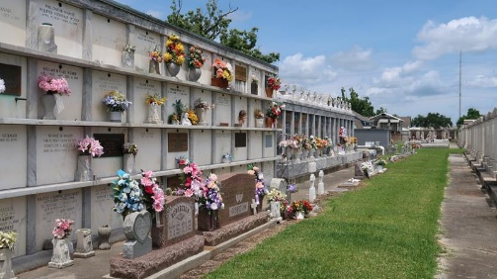

SCHNYDER – Of Reserve, La., on Friday, July 3, 1953 at 4:30 o’clock p.m. Pierre Schnyder, beloved husband of Mrs. Marie Cohn Schnyder, father of Claude and Pierre Schnyder Jr., of Reserve, La.; Reynold Schnyder of New Orleans; Godfrey Schnyder of Los Angels, Calif.; Mrs. Victoria Phillips of Greensboro, N.C.; Mrs. Doris Fontenot and Mrs. Edwina Martin of New Orleans; Mrs. Irene Andry and Miss Paula Schnyder of San Francisco, Calif., and Mrs. Daisy Glover of Los Angeles, Calif., and the late Dennis Schnyder, deceased; also survive by 30 grandchildren and three great-grandchildren.
Relatives and friends of the family are respectfully invited to attend the wake services on Sunday night at the Reserve Funeral Home, Reserve, La., from whence the funeral will take place on Monday, July 6, 1953, at 9:45 o’clock a.m., followed by requiem mass at Our Lady of Grace church. Father Turner officiating. Interment in St. Peter’s cemetery, Reserve, La.
Reserve Funeral Home in charge.

Unknown newspaper clipping

