Pierre C. Schnyder
June 14, 1916 – September 4, 1986

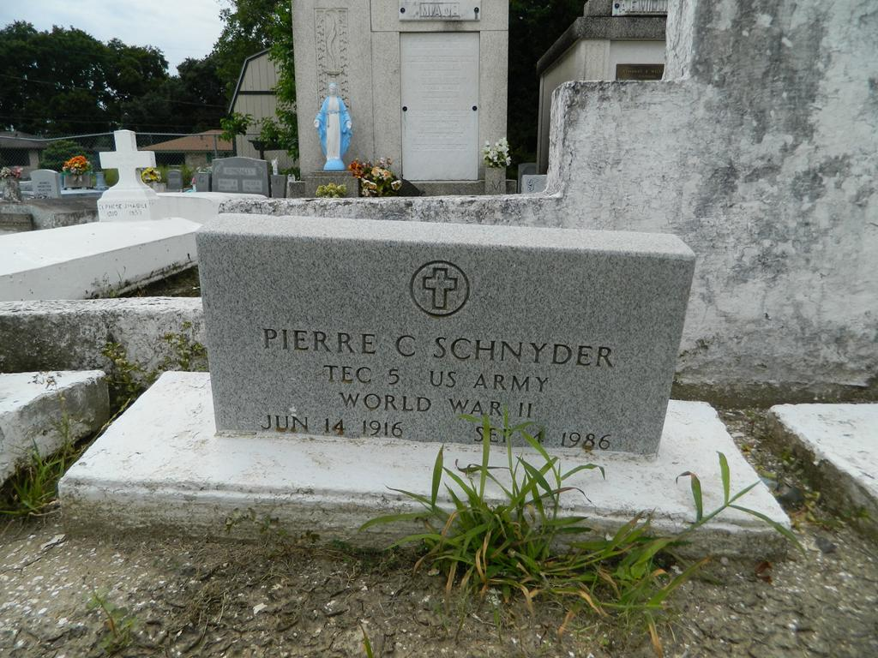

SCHNYDER

Pierre C. (Pete) Schnyder of Reserve, LA; on Thursday, September 4, 1986 at 10:25 a.m. Husband of the late Edna Roussell Schnyder, Father of Allen, Paul, Gregory and Ronald Schnyder of Reserve, Evangeline Johnson of LaPlace, LA, Nicholas Schnyder of Winston Salem, NC, Leo Schnyder and Marjorie Noble of Los Angeles, CA.
Son of the late Jeanne and Pierre A. Schnyder. Brother of Reynald (Bumble Bee) Schnyder of Reserve, Godfrey Schnyder and Daisy Glover of Los Angeles, Paula Lafargue of San Francisco, CA, Edwina Martin of New Orleans, the late Dennis and Claude Schnyder, Victoria Phillips, Irene Andry and Doris Fontenant. Father-in-law of Shirley James Schnyder of Reserve, Yvonne Schnyder of Winston Salem, NC, Annie Ruth Schnyder of Los Angeles and Norward Johnson of LaPlace; also survived by 23 grandchildren, nieces, nephews, cousins, other relatives and friends.
Relatives and friends of the family also pastors and parishioners of Our Lady of Grace Catholic Church of Reserve and all neighboring churches and employees of Sew Plastic and former Godchaux-Henderson Sugar Refinery are invited to attend the Funeral Mass. Services at our Lady of Grace Catholic Church, Reserve, Tuesday, September 9, 1986 at 10:00 a.m. Father J. Begay, celebrant. Interment in St. Peter Cemetery, Reserve in the family plot. Wake services at Robottom Mortuary, Reserve, Monday, September 8, 1986. Visitation at the Mortuary after 5:00 p.m. Recitation of the Rosary at 8:00 p.m.

Unknown newspaper clipping

