Reynold Joseph Schnyder
April 21, 1907 – December 23, 1986

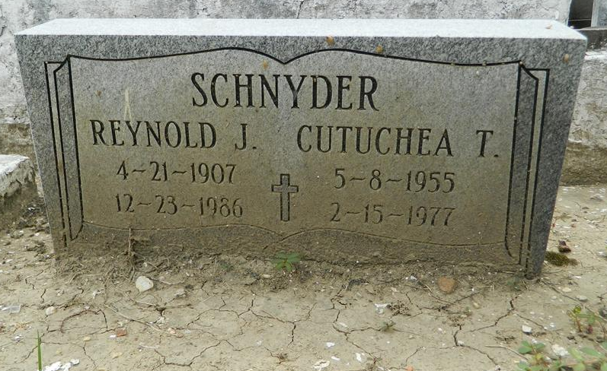

SCHNYDER

Reynold Joseph Schnyder of Reserve, LA, on Tuesday, December 23, 1986 at 1:45 p.m., beloved husband of Helen Lavins Schnyder; father of Raynold, Jr., Clayton, Harold, Donald, Judith, Yoland, Sedgie, Kevin, Kirk, Keith, Tangie, Ingrid, Demetrius, Tiffany, Sean, Yvette, Remy, Victor and Victoria; son of Pierre and Jeanne Schnyder; brother of Daisy, Poland, Edwina, Godfrey, the late Doris, Irene, Victoria, Claude, Dan and Pierre; also survived by 25 grandchildren, 6 great-grandchildren, nieces, nephews, other relatives and friends.
Relatives and friends of the family, also pastors, officers and members of Our Lady of Grace Catholic Church, Reserve, are invited to attend the funeral mass. Services at Our Lady of Grace Catholic Church, Monday, December 29, 1986 at 11:00 a.m. Father J. Begay, Celebrant. Visitation at the church, Monday morning, from 9:00 until mass time. Interment in St. Peter Cemetery, Reserve.
Serviced by Robottom.

Times-Picayune, New Orleans, Louisiana
Sunday, December 28, 1986, p. 20

