Geraldine (Triche) Scioneaux
November 15, 1938 – November 17, 2006

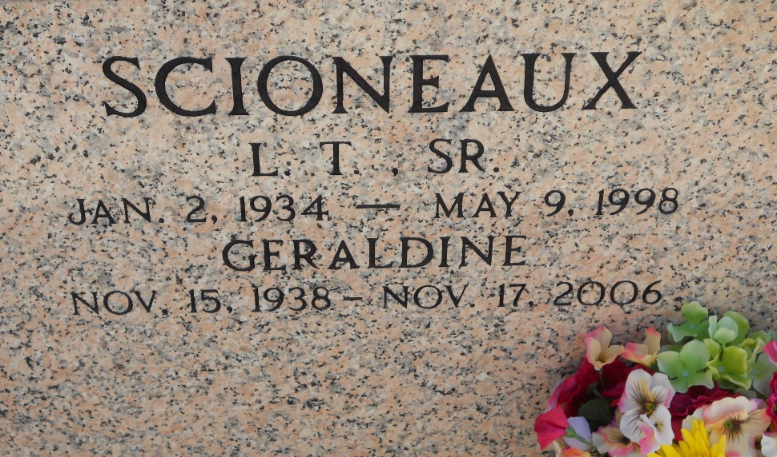
Photo by Team T-Lo

Geraldine Triche Scioneaux on Friday, November 17, 2006 at 11:00 p.m. Beloved wife of the late L.T. Scioneaux, Sr. Mother and mother-in-law of L.T. Jr. and Karen Scioneaux, Donnie Scioneaux, Brian and Laurette Scioneaux, Cynthia and Gerald Duhe and Lisa and Huey McDonald.
Daughter of the late Ernest Sr. and Effie Triche. Sister of Dolores Jacob, Bonnie Clement, Gail Baker, Carol and E.J. Triche, Jr., also the late Joanne Bossier and Dale Triche. Also survived by 8 grandchildren and 2 great-grandchildren. Age 68 years. A native of and resident of Reserve, LA.
Relatives and friends of the family are invited to attend services. Visitation at MILLET-GUIDRY FUNERAL HOME, 2806 W. Airline Hwy., LaPlace, LA on Monday, November 20, 2006 from 9:30 a.m. until 12:45 p.m. Followed by Religious Services at St. Peter Catholic Church, Reserve, LA at 1:00 p.m. Burial in Church Cemetery.

The Times-Picayune, New Orleans, Louisiana
November 19, 2006

