Perry Joseph. Scioneaux Sr.
May 7, 1956 – November 21, 2025

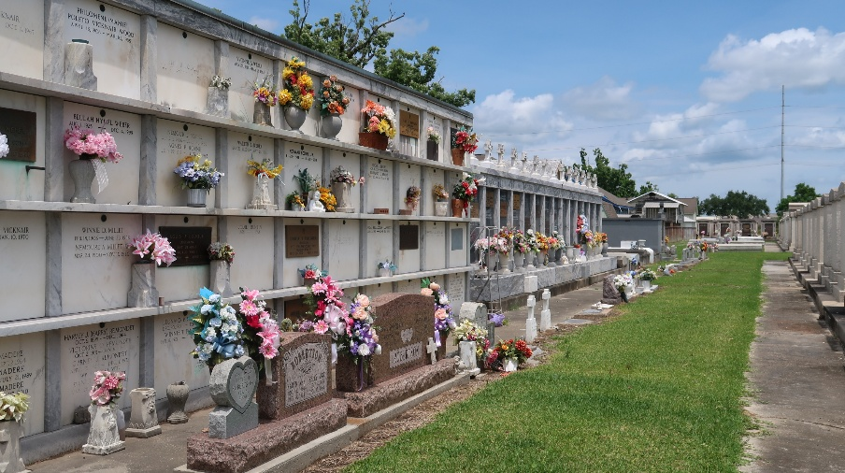
Photo by Team T-Lo

Perry J. Scioneaux, passed away on Friday, November 21, 2025 surrounded by his family at the age of 69. He was born in Reserve, LA and was a life-long resident of Reserve, LA.
Beloved husband of Kim Trosclair Scioneaux. Loving father of Perry "PJ" Scioneaux, Jr. (Hilary), Megan Scioneaux and the late Brynn Scioneaux. Grandfather of Haley Scioneaux and Paige Scioneaux. Soon to be Great-grandfather of Grayson Perry John Lauff. Son of the late Betty LeBlanc Scioneaux and Edwin "Shot" Scioneaux. Brother of Adeline Scioneaux, Janel Villeret (the late, Al) and Karen LeBlanc (Lee). Son-in-law of the late O.J. and Rosetta Trosclair. Also survived by nieces and nephews.
Relatives and friends are invited to attend the Visitation and Funeral Mass at St. Peter Catholic Church, 1550 Hwy 44, Reserve, LA on Tuesday, November 25, 2025. Visitation will be held at the church from 9:00 a.m. to 12:00 p.m. followed by a Funeral Mass at 12:00 p.m. Interment in St. Peter Cemetery, Reserve, LA.
In lieu of flowers, please make a donation in his memory to St. Peter Catholic Church, 1550 Hwy 44, Reserve, LA 70084.
Millet-Guidry Funeral Home, LaPlace, Louisiana

