Warren Louis Scioneaux
February 10, 1929 – August 8, 2013

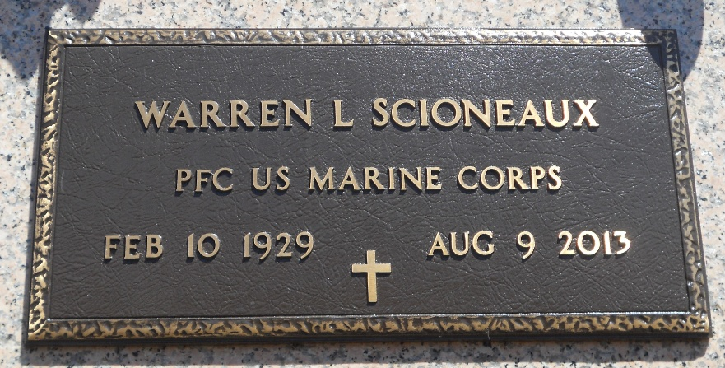
Photo by Team T-Lo

Warren Scioneaux died on Thursday August 8, 2013.

Former husband of Ethel Hymel Scioneaux. Beloved father of Jean Burns, Nancy Freitas and Janice Bruce. Also survived by 9 grandchildren and 13 great-grandchildren.

Son of the late Louis and Jeanne Scioneaux. Brother of Alta Pertuis and the late L.T. and Lester Scioneaux. Age 84. A native of Reserve and resident of Tickfaw.

Relatives and friends are invited to attend services. Visitation at Millet-Guidry Funeral Home, 2806 W. Airline Hwy. LaPlace, LA on Monday August 12, 2013 from 10:00am to 12:00 noon, followed by Religious Services in The Funeral Home Chapel at 12:00 noon. Burial in St. Peter Cemetery, Reserve, LA.

The Times-Picayune, New Orleans, Louisiana
August 10-11, 2013

Note difference in death date in obit and tombstone

