Addam Victor Scott
June 27, 1967 – September 27, 2006

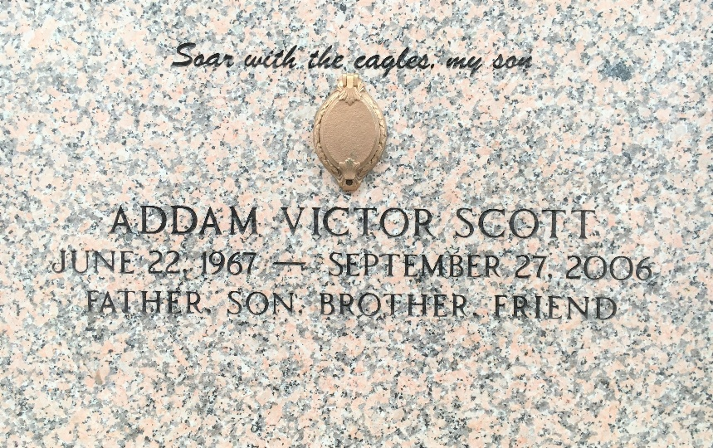
Photo by Team T-Lo

Addam Victor Scott died on Wednesday, September 27, 2006 from congestive heart failure at Tulane Hospital in New Orleans. Mr. Scott, age 39, was a carpenter, a native of Kewanee, Illinois and a resident of LaPlace, LA.
Survived by: father, Leonard D. Scott of Iowa and Maryann Wancket of LaPlace, LA; paternal grandmother, Darlene Scott of Illinois; son, Bradley Scott of LaPlace, LA; daughters, Terry Lynn Scott of LaPlace, LA; brother, Allen Verdick of West Monroe, LA; sister, Diana Vitrana of Houma; and 2 half-brothers, Shane and Luke Scott, both of Illinois.
Relatives and friends of the family are invited to attend visitation on Sunday, October 1, 2006 at H.C. Alexander Funeral Home of Norco from 3:00 P.M. to 6:00 P.M. and again on Monday, October 2, 2006 from 8:00 A.M. until Christian service time at 12:00 noon. Father Ed Lauden officiating. Interment in St. Peters Mausoleum in Reserve, LA.
In lieu of flowers, donations may be made to the American Heart Association. H.C. Alexander Funeral Home of Norco in charge of arrangements.

The Times-Picayune, New Orleans, Louisiana
September 29, 2006

