Ranae Elizabeth (Toney) Scott
September 5, 1972 – August 11, 2005

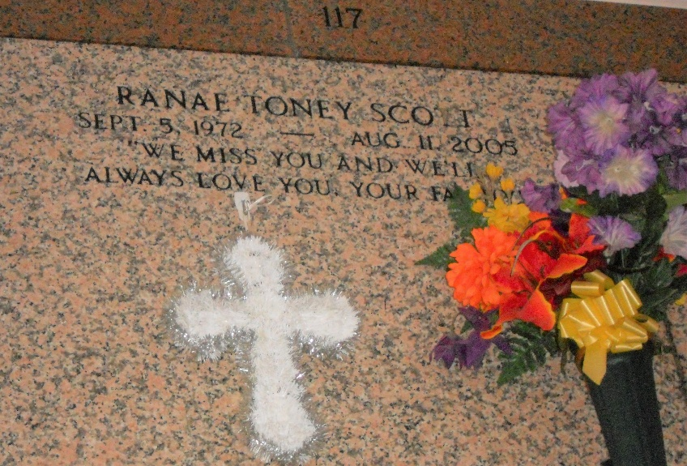
Photo by Team T-Lo

Ranae Elizabeth Toney Scott, of LaPlace, LA on Thursday, August 11, 2005. Daughter of Eddie Washington and Barbara Toney. Beloved wife of Kendrick Scott. Mother of Kendrinecia, Kendrick, Jr., and Keilah Scott. Sister of Joy M. Toney. Daughter-in-law of Barbara Anthony and Whitney Scott. Also survived by a host of aunts, uncles, cousins, sisters and brothers-in-law, nieces, nephews, other relatives and friends. A native of Reserve, LA and a resident of LaPlace, LA. Age 32 years.
Relatives and friends of the family, also pastor, officers, and members of the Milesville Memorial C.O.G.I.C, Employees of Wal-Mart, Donnie's Chevon, Faculty, Staff and Student Body of East. St. John Elem. School, are invited to attend the Funeral Services on Thursday, August 18, 2005 at 10:00 A.M. from the Milesville Memorial C.O.G.I.C, Apple St., LaPlace, LA. Bishop Ronald Frank, officiating. Entombment St. Peter Catholic Church Cemetery, Reserve, LA. Visitation on Wednesday, August 17, 2005, 5:00 - 7:00 P.M. from the BALONEY FUNERAL HOME, L.L.C., 399 Earl Baloney Drive, Garyville, LA, on Thursday after 8:00 A.M. at the church.

The Times-Picayune, New Orleans, Louisiana
August 17, 2005

