Rodney DeCarl Scott
January 20, 1959 – August 18, 2023

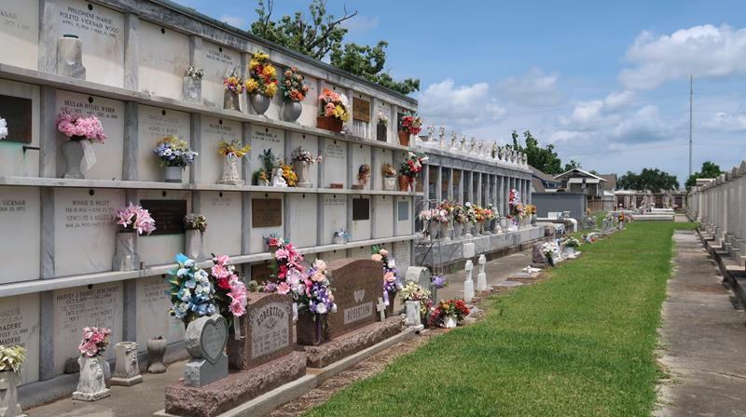

On August 18, 2023. Rodney DeCarl Scott passed away unexpectedly at the age of 64. Our family was not expecting Rodney’s life to be taken away so soon but God’s will be done. We are devastated by this huge loss but grateful for the fullness and richness his short life provided to so many. He had one of the most compassionate souls of anyone. He lit up the room with his wide infectious smile. He possessed a sweet disposition, had a heart of gold and was giving beyond belief. He exemplified the role of loving husband, compassionate father, doting grandfather, and cherished friend to all fortunate enough to have crossed paths with him. He will forever be missed.
Rodney was born on January 20, 1959 in Lutcher, LA. He received his education in St. John the Baptist Parish and graduated from Leon
Godchaux High School in Reserve, LA in 1977 where he was a member of the basketball team, the 4-H Club, and Future Business Leaders of America. He continued his academic journey at Texas Southern University in Houston, TX.
He accepted Jesus Christ at an early age, baptized by the late Rev. Ernest Taylor, Sr., at Greater New Plymouth Rock Baptist Church. Where he sang in the youth choir. Rodney was a man of many interests and talents. He was employed at DuPont/Denka for almost 44 years. His passion; however, was fishing which he shared with two of his grandkids, ‘Polecat” and “Wookie”. His love of fishing led him to become one of the founding members of the Gold Rod Bass Club. Another passion was cooking and on any given day he could be found in the kitchen or on the patio stirring up meals for his family and friends. He loved working with his hands building things, often with no blueprint. He possessed the ability to take things apart, repair them and put them back together. He enjoyed creating eye catching landscape projects. Showing the fruits of his labor from gardening was just one more avenue he pursued and excelled in. Rodney was a die hard Saints fan. Even when some decided to wear bags on their heads, he was there with that bright smile bravely cheering them on. He and his wife often traveled to Saints away games to show support and hope for a victory.
Rodney leaves to mourn but cherish his memories, his wife of 43 years, Jacqueline Renee’ Washington Scott; three children: Corey DeCarl Scott and wife Crystal of Alexandria, LA, Kelsey Renee’ Scott of Baton Rouge, LA, and Coi DeCarl Scott of Paulina, LA; six grandchildren: Braylin-Jacobi, Zion, Ryleigh, Gracilyn, Sage, and Lilith; one brother, Mathew Meredith of League City, TX; three sisters: Thelma Williams of Houston, TX, L. Meredith Johnson of Mesquite, TX, and Brenda Meredith of Las Vegas, NV; a number of sisters-in-law and brothers-in-law, a host of nieces, nephews, other relatives and the many friends he constantly made.
He was preceded in death by his parents, Catherine Scott Harris and Clement Scott; mother-in-law, Bobbie Jo Washington, grandparents -Joe and Louise Brown, Henry and Irma Scott; and sister, Lolita D. Moore.
Though Rodney was a man of few words, he was a man with a multitude of talents and touched so many lives. He will always be remembered by his heartbroken wife and will forever remain in the hearts of his family, friends and those that loved and knew him. Funeral Services for Rodney will be held on September 2, 2023, at New Wine Cristian Fellowship, 1929 W. Airline Hwy., LaPlace, LA 70068. Visitation will begin at 9AM, with service to follow at 11AM. Rodney will be laid to rest at St. Peter’s Catholic Church Cemetery in Reserve, LA.

Treasurers of Life Funeral Services, Gramercy, Louisiana

