Lois Ann (Sanders) Shorts
March 25, 1952 – August 21, 2025

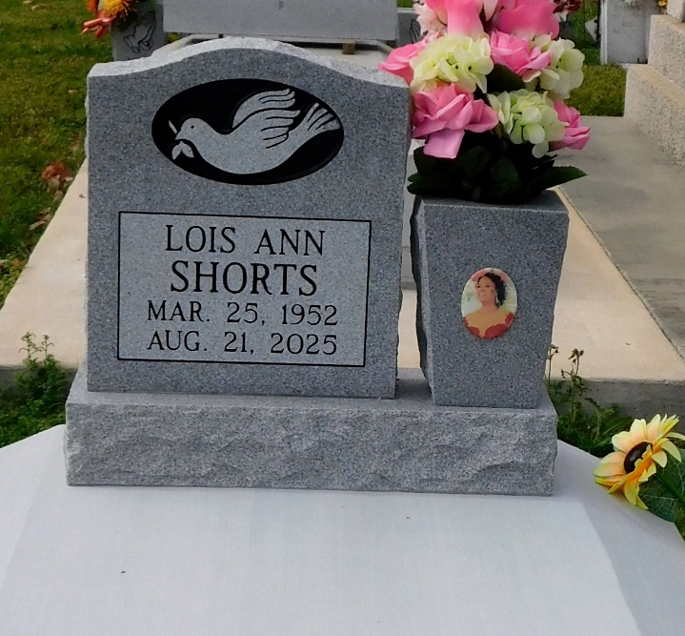
Photo by Mary Agnes Hammett

Lois Ann Sanders Shorts was born on March 25, 1952, to the late Alger Joseph Sanders, Sr and Victoria Kay Williams Sanders in New Orleans, LA. She was reared in Reserve, LA. She attended Our Lady of Grace School in Reserve, Mary McCleod Bethune HS in Norco, LA and San Bernadino HS in San Bernadino, CA.
On May 30, 1970, she married her true love, Elbert Shorts, Sr. and during their 55 years of marital bliss, three children were born. Lois was employed by the St. Charles Grain Elevator in Destrehan, LA retiring after 25 years. She was baptized here at St. Matthew BC by Pastor Fred T. Porter.
Lois was known for her warm smile and generous heart. She had a unique creative talent for designing floral arrangements. She often bestowed her crafts at church banquets, funerals, and weddings. Lois enjoyed showering her children and grandchildren with unconditional love. She always wanted to look her best, one could say she was a fashionista.
On Thursday, August 21, 2025, at 7:05 pm, surrounded by family, Lois answered the call of her LORD and transitioned from earth to heaven’s reward. She leaves to cherish her memories, her loving husband, Elbert Shorts, Sr, three devoted children, Sabrina (Otis, Sr) Ben, Joy (Tyray) Jenkins, and Elbert (Keisa) Shorts, Jr; four sisters, Bonnie (Donald) Stevenson, Cabrina (Carl) James, Veronica & Wanda Sanders; an honorary daughter, Michelle (Graylin) Colbert; 8 grandchildren, Otis, Jr, Joyla, Joia, Jason, Ebert, III, Ahriel, Shante, & Donovan; 9 great-grandchildren; a brother-in-law, Cardell (Jeanette) Shorts; two aunts, Ethel Mae Fobb and Mildred Williams; a godchild, Romeo Roberts and a multitude of nieces, nephews, cousins and friends.
She was preceded in death by her parents, siblings Alger, Jr, Wayne, Woodrick, Kevin, and Joyce Sanders and one granddaughter, Mercedes. Lois will be remembered for her love of family and kindness to others. Her legacy will continue in all who was blessed to know her.
Relatives and friends of the family, Pastors, officers and members of St. Matthews Baptist Church and all neighboring Churches are invited to a Celebration of Life Service at 12:00pm on Saturday, August 30, 2025, at St. Matthew Baptist Church, 604 E S Johnson Street, New Sarpy, LA 70078. Rev. Dr. Albert Bailey, Pastor- Officiating. Visitation 9:00am until time of service at the above-named church. Interment St. Peter Catholic Church Cemetery, 1550 LA-44, Reserve, LA 70084.

Patrick H. Sanders Funeral Home & Funeral Directors, LLC, LaPlace, Louisiana

