Ruby (Beadle) Sillars
January 10, 1924 – September 19, 1987

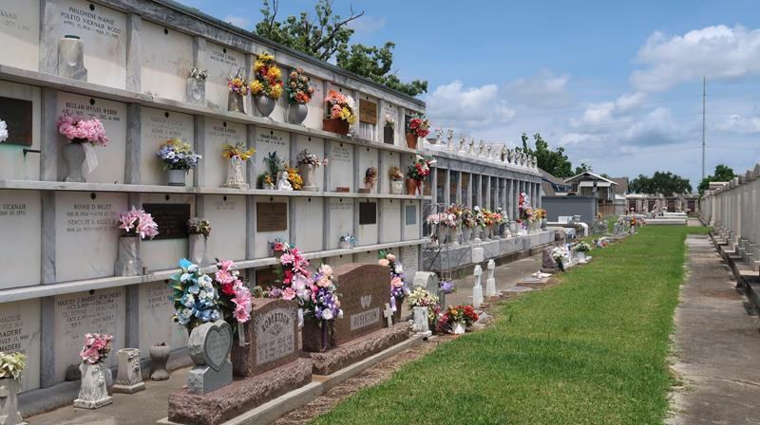

SILLARS

Ruby Beadle Sillars, on Saturday, September 19, 1987 at 8:00 o’clock a.m., beloved wife of Mr. Thomas C. Sillars of new Orleans, LA; mother of Amanda Dudenhefer of Slidell, La and Jeb Charles Sillars of Covington, La; Daughter of the late Mr. and Mrs. Fank B. Beadle; sister of Henry, Frank, Daniel and Dudley Beadle, all of Reserve, LA, Richard Beadle of Shreveport, LA, Milton Beadle of Indianapolis, IN, Wayne Beadle of Norco, LA, Agnes Levetro and Dianne Allen of new Sarpy, LA, Myrtle Love and Irene Dardis of Metairie, LA; grandmother of Chad and Countney Dudenhefer, and Cassidy Sillars; daughter-in-law of Mary Sillars of New Orleans, LA; age 63 years; a native of Reserve, LA and a resident of New Orleans, LA for the past 40 years.
Relatives and friends of the family and the past and present staff members of Abramson High School are invited to attend the funeral services from Millet Funeral Home, Reserve, LA, on Monday, September 21, 1987 at 10:30 o’clock a.m., followed by religious services at St. Peter’s Catholic Church, Reserve, LA. Interment in St. Peter Cemetery, Reserve, LA. Friends may call from 6:00 p.m. to 10:00 p.m., on Sunday, September 20, 1987 and from 8:00 a.m. until services on Monday. In lieu of flowers, donate to Parkinson’s Disease Foundation. Arrangements by Millet Funeral Home.

Unknown newspaper clipping

