Dillon Warren Simmons
March 3, 1986 – December 16, 2006

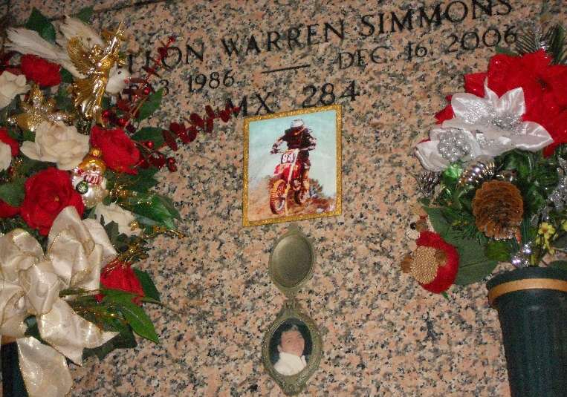
Photo by Team T-Lo

Dillon Simmons, on Saturday, December 16, 2006 at 12:30 a.m.

Beloved son of Crystal Vicknair and Warren Simmons. Brother of Justin and Warren Simmons. Grandson of Priscilla and Richard Vicknair and Gail and Betty Simmons. Stepson of Jeanne Simmons. Age 20. A native and resident of Reserve.

Relatives and friends of the family are invited to attend services. Visitation at Millet-Guidry Funeral Home, 2806 W. Airline Hwy, Laplace, on Wednesday, December 20, 2006 from 8:00 am to 10:00 am. Followed by Religious Services at the funeral home chapel at 10:00 am. Burial in St. Peter Cemetery, Reserve, LA.

Times-Picayune, New Orleans, Louisiana
December 19, 2006

