Elizabeth (Kliebert) Simon
November 25, 1897 – February 8, 1980

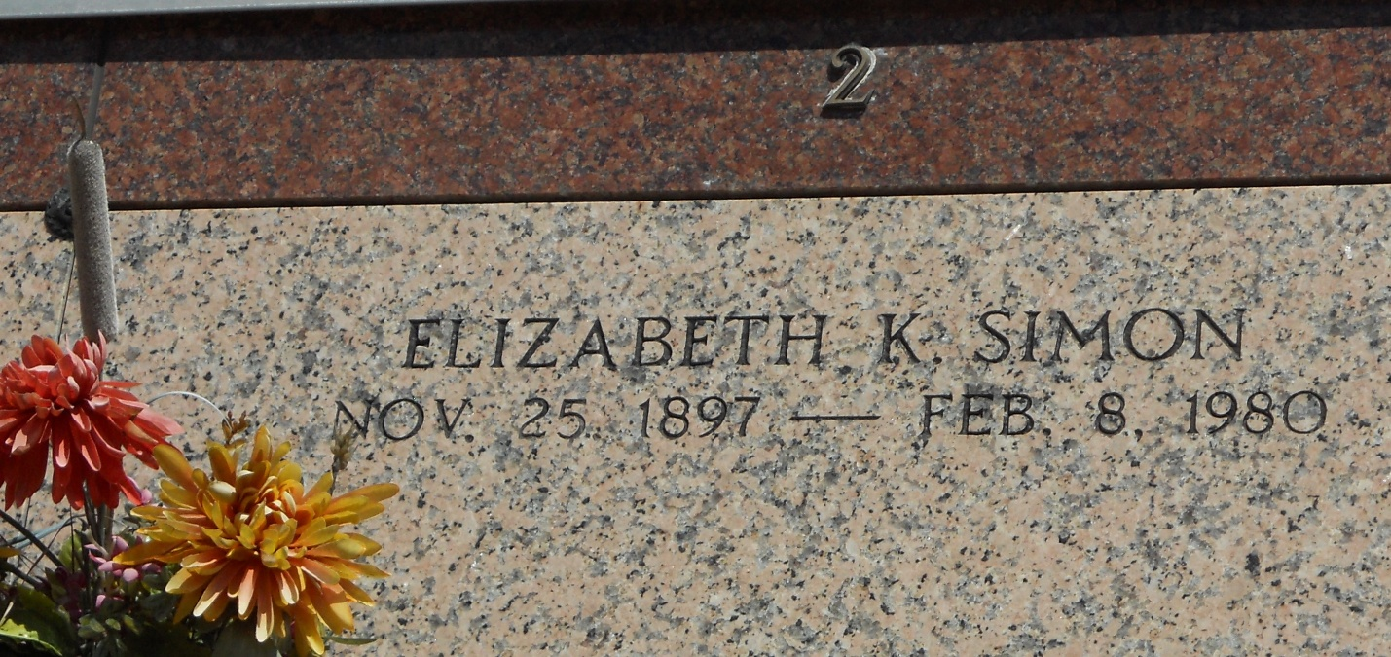
Photo by Team T-Lo

SIMON

Elizabeth K. Simon, on Friday, February 8, 1980 at 12:45 a.m., beloved wife of the late Sidney Simon, sister of Josephine Boe, aunt of Amelia Laiche, O’Neil Boe, John Boe, Helda Crumpton, James Boe, Rita Bandanna, Leonard Boe and Laura Hutchinson, cousin of Francis Oubre, daughter of the late Mr. & Mrs. James Klibert, age 82 years and a resident of Reserve, La. for the past 10 years.
Relatives and friends of the family are invited to attend the funeral services from the Millet Funeral Home, Reserve, La., on Saturday, February 9, 1980 at 10 a.m. Followed by religious services at St. Peter Church. Interment in St. Peter Cemetery, Reserve, La. Friends may call from 5 p.m. until 11 p.m. on Friday, and from 8 a.m. until services on Saturday.

Unknown newspaper clipping

