Kenneth Joseph Simon
June 14, 1941 – January 8, 2017

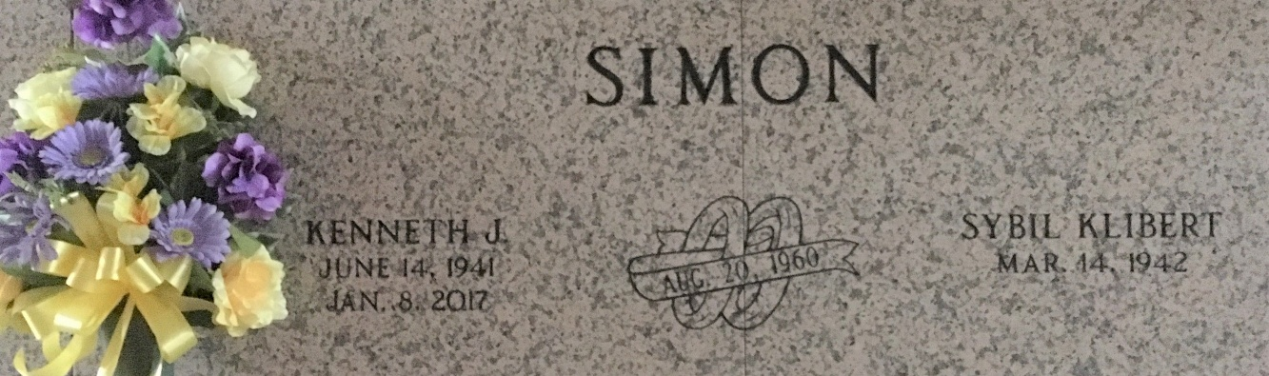
Photo by Team T-Lo

Kenneth “Kenny” Joseph Simon, age 75, passed away on Sunday, January 8, 2017 at the Carpenter House in River Ridge, LA.
He is survived by his wife, Sybil Klibert Simon; sons: Todd (Mary), Gregg (Jodie), Bruce (Karen) and daughter Stacy Vicknair (Don) as well as a sister, Betty S. Becnel. He will be greatly missed by his 6 grandchildren and 5 great-grandchildren. He was preceded in death by his parents, Sidney Simon and Isabella Aucoin Simon.
A visitation in his honor will be on Thursday, January 12, 2017 at St. Peter Catholic Church in Reserve from 9:00 a.m. until 11:00 a.m. followed by a Mass of Christian Burial at 11:00 a.m. Burial will follow at St. Peter Cemetery in Reserve, LA.
ROSE LYNN FUNERAL SERVICES, Lutcher, Louisiana

