Rene J. Simon
June 28, 1929 – April 12, 2023

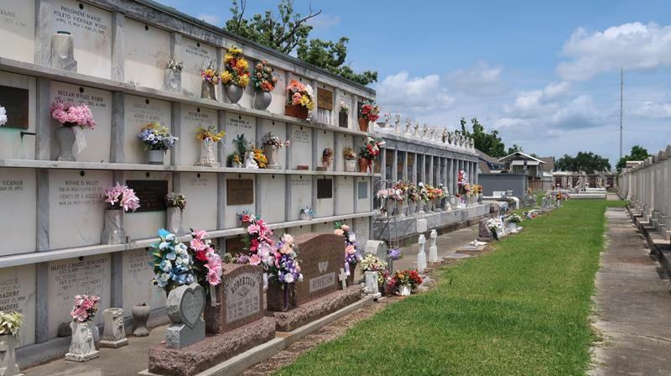

Rene J. Simon was born in June 28, 1929 and passed away peacefully on April 12, 2023 surrounded by his loving family.
He was born in Vacherie, LA but a long time resident of Reserve, LA. Devoted husband of Roberta Simon for 64 wonderful years. Father of Pam Simon and Darryl Simon, Sr. Grandfather of Ashley Simon and Darryl Simon. Jr. (Aimee').
Son of the late Joseph and Lena Simon of Reserve, LA. Survived by his sister, Lois Jacob and preceded in death by siblings Andrew Simon (Florette), Henry Simon, Antoine "Buck" Simon (Leona), Willie Simon, Ellis Simon, Earl Simon, Arthemise Rebler (Fredrick), Velma Williams (Frank), Therese Brennan (Albert) and Elise Simon. Also survived by many nieces and nephews.
While he was a young man, Rene spent time at Ponchatoula Beach with his beloved wife Roberta and at his favorite fishing camp in Manchac. He also enjoyed hunting with his son and grandson. He loved watching football, especially Riverside. In his last years, he could be found in his garden planting tomatoes or in his favorite recliner watching cowboy movies. He always looked forward to a crawfish or a crab boil with his family. His laughter, his personality and his presence will be missed tremendously.
The family would like to give many thanks to Denise and Melissa with Compassus Hospice for their excellent care and guidance.
Relatives and friends are invited to attend a Funeral Mass at 11:00 AM on Tuesday, April 18, 2023 at St. Peter Catholic Church, 1550 Hwy 44, Reserve, LA 70084. Visitation will begin at 9:00 AM. Interment will be in St. Peter Catholic Cemetery.

Millet-Guidry Funeral Home, LaPlace, Louisiana
Apr. 15, 2023

