Roberta (Hoover) Simon
March 8, 1936 – November 9, 2024

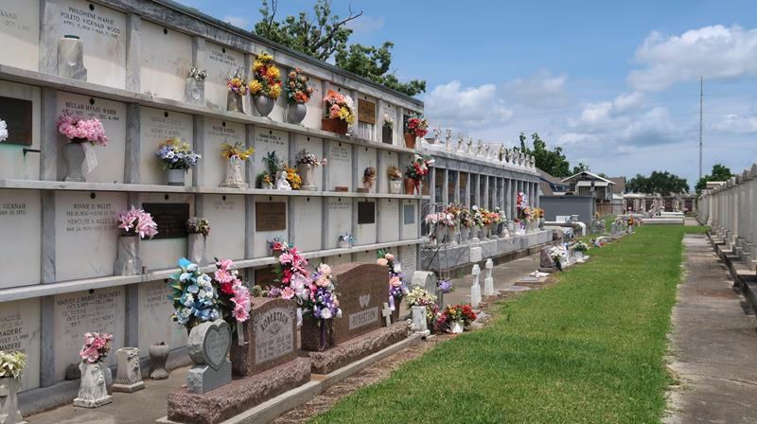

Roberta Hoover Simon was born on March 8, 1936, and passed away peacefully on November 9, 2024, at the age of 88. Born in Independence, LA but a long-time resident of Ponchatoula, LA and Reserve, LA.
Loving wife of 65 years to Rene J. Simon. Mother of Pam Simon and Darryl Simon Sr. Grandmother of Ashley Simon and Darryl Simon Jr. (Aimee') and great grandmother to Joseph.
Daughter of the late Robert and Eve Hoover of Independence. Survived by her brother, Wayne Hoover (Nancy) and preceded in death by her husband, Rene' and siblings Thelma Borne (Daniel), Judy Devall (Billy), Mary Wolford (David) and her twin brother Robert Hoover. Survived by many nieces and nephews.
Roberta was a familiar face to everyone and truly never met a stranger. She was the friendly face behind the deli counter at Dons Country Store for many years and a regular player at Bingo, where she earned the nickname "Bingo Bert". Other than bingo, she loved playing cards, spending time with her family, taking trips to California, cooking, attending crawfish boils and BBQs with her family and enjoying her grandson, "dat lil boy" Joseph.
Roberta's family would like to give thanks to the staff of Twin Oaks nursing home and Harmony Hospice for their continuous care and compassion.
Services will be held at a later date.

Millet-Guidry Funeral Home, LaPlace, Louisiana
November 15, 2024

