Rosemary (Sanders) Simon
June, 1937 - December 10, 2024

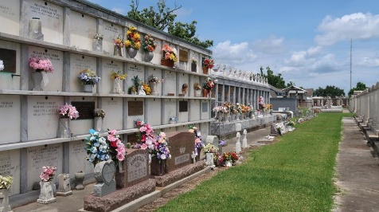

Rosemary Sanders Simon, passed away peacefully on Tuesday, December 10, 2024, surrounded by her family at home. She was born in June 1937 and was a lifelong resident of Reserve, LA. She was the daughter of the late Adelaide (née Gauff) and Gilbert Sanders. For 64 years, she was the loving and devoted wife of Sterling A. Simon.
Rosemary attended Our Lady of Grace Elementary School and was a member of the first Our Lady of Grace High School graduating class in 1955. She graduated from Xavier University of Louisiana with a Bachelor of Arts degree in Education in 1959. Throughout her career, which spanned over 25 years, she worked as a high school and middle school educator in the Orleans and St. John the Baptist Parish Public School systems. She loved being a teacher, and invested her time, talent, and energy in developing the whole student.
Following retirement, Rosemary worked as a General Education Diploma (GED) instructor in the St. John the Baptist Parish Jail. There, she succeeded in helping inmates obtain diplomas that would allow them to improve their ability to successfully return to society. Rosemary was always willing to assist and volunteered her teaching and writing talents in various capacities. An outstanding cook, she often made meals in support of her loved ones at home and at church, where she was active in numerous ministries.
Rosemary is survived by her husband, Sterling, along with her children, Michéle, Kyle (Patricia), Jenelle (Joseph), and Courtney (late Erroll). She was the sister of Shirley (late Clifford), Ollie (late James), and the late Sidney (late Janice). She was the proud grandmother of Brandon (Tina), Ashley (Chris), Cameron, Kyra, Mia, Kayla, Zachary, Simone, Chase, Caleb, and great-grandmother of Jaden, Zoë, Isaiah, and Noelle.
Relatives and friends, Pastors, Officers and Members are invited to attend a Celebration of Life at New Wine Christian Fellowship Church, 1929 W Airline Hwy, Laplace, LA 70068, on Friday, December 20, 2024. Visitation begins at 9:00 a.m., with the service starting at 11:00 a.m. Interment will follow at St. Peter Cemetery, 1550 LA-44, Reserve, LA 70084.
In lieu of flowers, the family requests that donations in memory of Rosemary Sanders Simon be sent to: Xavier University of Louisiana, 1 Drexel Drive, New Orleans, LA 70125, or online at https://giving.xula.edu/.

Patrick H. Sanders Funeral Home & Funeral Directors, LLC.
December 15, 2024

