Eddie J. Simoneaux
August 20, 1920 – September 27, 2004

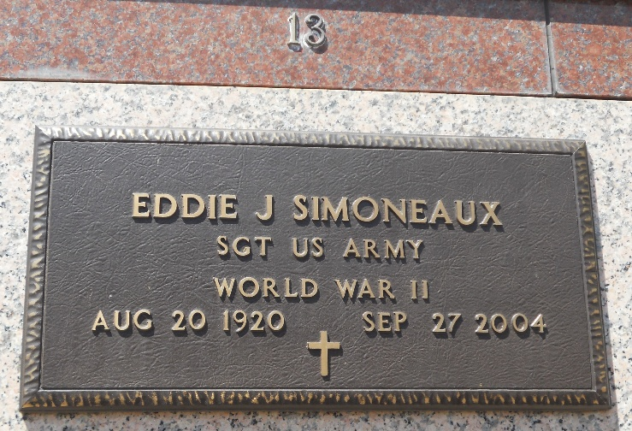
Photo by Team T-Lo

Eddie Simoneaux on Monday, September 27, 2004 at 4:00 PM. Beloved husband of the late Florence (Flo) Martinez Simoneaux. Father and father-in-law of Gloria and Sherry Alexander and Barbara and Joey Cassioppi. Grandfather and grandfather-in law of Scott and Shelley Alexander, Kim Alexander, Reed and Laurie Alexander, Troy and Amy Cassioppi, Jamie and Tina Cassioppi and Staci and Gerald Bertucci. Also survived by 8 great grandchildren. Brother of Edith Kern, Beatrice Boudreaux and the late Claiborne, Clebert, Clay and Henry Simoneaux. All of us who knew him knew he was a great Dad, Super Grandfather, Terrific Great-grandfather and wonderful friend.
He was a good man who taught us the importance of love by his own example. We will miss him very much. We will keep him alive through our own example of the legacy he has passed on to us. Please join us in keeping him alive.
Special thanks to Evangeline of Ormond Nursing Home and Dr. Cusco for the outstanding care given to our father. Age 84 years, a native of Napoleonville, former resident of Reserve for 27 years and a resident of Covent for the past 31 years.
Relatives and friends of the family, also employees of Evangeline of Ormond Nursing Home, Destrehan, LA are invited to attend services. Visitation at MILLET-GUIDRY FUNERAL HOME, 2806 W. Airline Hwy., LaPlace, LA on Thursday, September 30, 2004 from 6:00 PM to 8:00 PM and on Friday from 8:00 AM to 9:45 AM followed by religious services at St. Joan of Arc Catholic Church, LaPlace, LA at 10:00 AM. Burial in St. Peter Cemetery. Reserve, LA.

The Times-Picayune, New Orleans, Louisiana
September 30, 2004

