Felix Simoneaux Jr.
May 24, 1905 – April 19, 2016

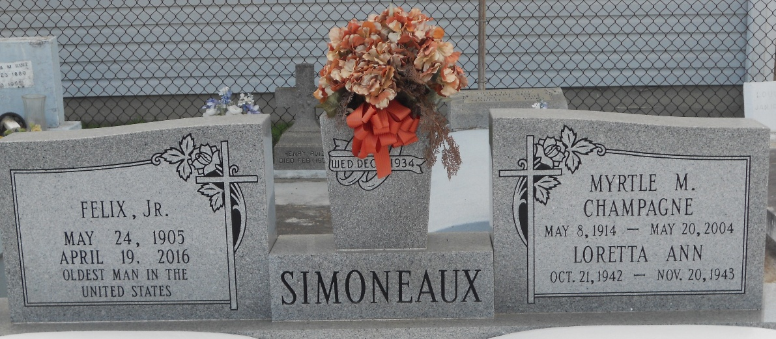
Photo by Team T-Lo

Felix Simoneaux, Jr. devoted husband and father went to join his beloved wife, Myrtle Champagne, on Tuesday, April 19, 2016 at 11:00 p.m. They enjoyed a very loving life together for 69½ years until her death. They had six children: Myrtle S. Robichaux (Bobby-Deceased); Audrey S Terrio (Alvin); Myra E. Simoneaux; Carey F. Simoneaux (Sharon Perilloux-Deceased); Perry Maurice Simoneaux (Jerry Arabie-Deceased).
He was preceded in death, by a daughter, Lorreta Anne Simoneaux and a grandson, Keith Robichaux. He is survived by 12 grandchildren, numerous great-grandchildren, and great-great-grandchildren. He was one of nine children of Felix Simoneaux, Sr. and Sedonia Vicknair.
Self-taught Carpenter by trade, he built his family home in which he still resided. He also built one daughter's home; added additions to another daughter's home, and completed finishing work on a 2nd floor addition to a son's home. He was a very hard working, talented southern gentleman. He recently was honored with a plaque, commemorative pin and documents in recognition of being the oldest living member of Carpenter's Union No. 1846, having served for 75+ years.
He was very highly respected and loved by anyone who knew him. He was also known for his delicious vegetables which he gave to family and neighbors. After retiring at 79, he began Truck Farming, bringing his produce into French Market in New Orleans. During WWII he worked for Higgins Ship Builders, building PT boats and landing drop ramp boats - the largest landing crafts used in the Normandy Invasion. He was the oldest living citizen of this country for the past 6 months.
Family and friends are invited to attend the Funeral Mass at St. Joan of Arc Catholic Church, 529 W. 5th St., LaPlace on Friday, April 22, 2016 at 12:00 p.m. Visitation at the church from 9:30 a.m. until 12:00 p.m. Interment in St. Peter's Cemetery. Arrangements by Millet-Guidry Funeral Home.

The New Orleans Advocate, Louisiana
April 21, 2016

