Florence “Flo” (Martinez) Simoneaux
December 20, 1920 – July 12, 2004

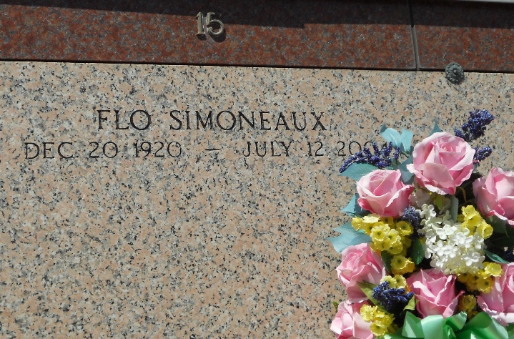
Photo by Team T-Lo

Florence (Flo) Martinez Simoneaux on Monday, July 12, 2004 at 12:30 A.M. Beloved wife of Eddie Simoneaux. Mother and mother-in-law of Gloria and Sherry Alexander and Barbara and Joey Cassioppi. Grandmother and grandmother-in-law of Scott and Shelley Alexander, Kim Alexander and Reed and Laurie Alexander, Troy and Amy Cassioppi, Jamie and Tina Cassioppi and Staci and Gerald Bertucci. Great-grandmother of Payton, Rylee, Josh, Darrin, Mason, Bailey, Bryce, Shawn and the late Colby. Sister of Lucille Blank and the late Marie Dugas, Enola, Annie, Paul, Jr., Clarence, Vannie, Lawrence and Joseph Martinez.
Each of us had a chance to tell her we love her and that it was okay to let go. She was a good woman who taught us the importance of love by her own example. We will miss her very much. We will keep her alive through our own example of the legacy she has passed onto us. Please join us in keeping her alive.
A special thanks to River Parish Hospital, Evangeline of Ormond Nursing Home and Drs. Cusco, Bailey and Pippin for the outstanding care given to our mother. Age 84. A native of White Castle, Louisiana. Former resident of Reserve and a resident of Convent for the past 31 years.
Relatives and friends of the family, also employees of Evangeline of Ormond Nursing Home, Destrehan, Louisiana are invited to attend services. Visitation at MILLET-GUIDRY FUNERAL HOME, 2806 W. Airline Highway, LaPlace, on Tuesday, July 13, 2004 from 6:00 PM to 8:00 PM and on Wednesday from 8:00 AM to 9:45 AM. Followed by religious services at St. Joan of Arc Catholic Church, LaPlace at 10:00 AM. Burial in St. Peter Cemetery, Reserve.

The Times-Picayune, New Orleans, Louisiana
July 13-14, 2004

