Lilly (Michel) Simoneaux
March 22, 1924 – November 3, 2016

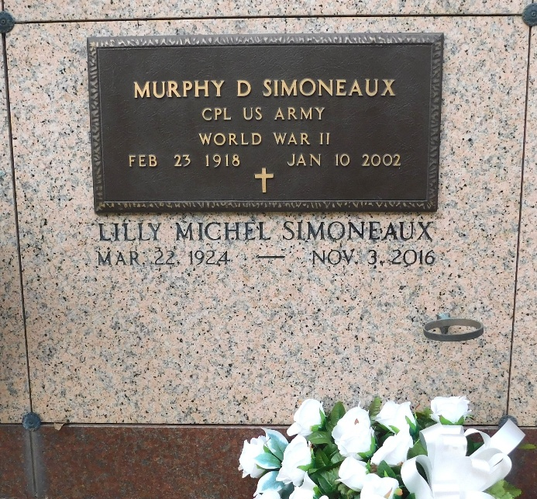
Photo by Mary Agnes Hammett

Lilly Michel Simoneaux passed away on Thursday, November 3, 2016. She was 92, a native of Convent, LA and resident of LaPlace, LA.
Beloved wife of the late Murphy Damian Simoneaux. Mother of Ralph Simoneaux, Sharon Triche, Brenda Lowry, Elaine Hintz and Debra Roussel. Daughter of the late Sidonia Oubre Michel and Ulric Michel. Sister of Roger Michel, Stella Roussel, Margaret Dunham and the late Lillian Davis, Arthur Michel, Raymond Michel, Ulric Michel, Jr. and Rene Michel. Also survived by 9 grandchildren, 13 great-grandchildren, a great-great-grandchild, nieces and nephews. She was preceded in death by a granddaughter.
The family would like to express their heartfelt appreciation to the staff of Ormond Nursing Home and St. Catherine's Hospice for their loving care.
Relatives and friends are invited to attend the funeral. A Funeral Mass will be celebrated at St. Joan of Arc Catholic Church on Saturday, November 5, 2016 at 11:00 a.m. Visitation at the church from 9:00 a.m. until 11:00 a.m. Interment in St. Peter Cemetery. Serviced by Millet-Guidry Funeral Home.

The New Orleans Advocate, Louisiana
Nov. 3 to Nov. 5, 2016

