Myrtle M. (Champagne) Simoneaux
May 8, 1914 – May 20, 2004

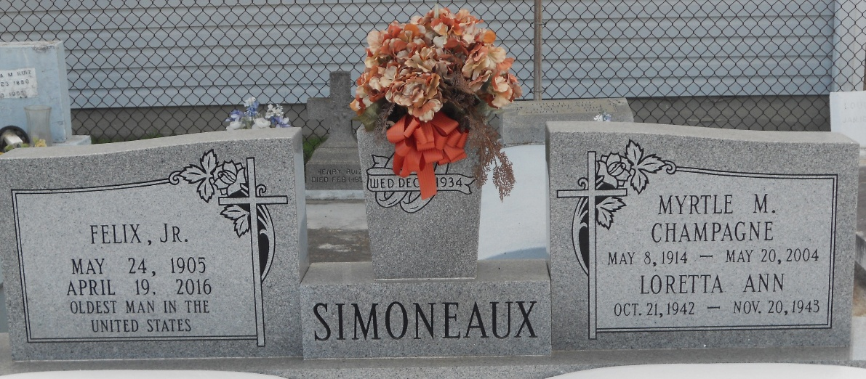
Photo by Team T-Lo

Myrtle Champagne Simoneaux on Thursday, May 20, 2004 at 9:22 p.m. at home. Beloved wife of Felix Simoneaux, Jr. Mother and mother-in-law of Myrtle and Robert (Bobby) Robichaux, Audrey and Alvin Terrio, Myra Simoneaux, Carey and the late Sharon Simoneaux, Maurice and the late Jerry Simoneaux, and also the late Loretta Simoneaux.
Daughter of the late Oscar and Amelia Champagne. Sister of the late Walter, Oscar Jr., and Griffin Champagne, Eva Roux, Amelia Robert, Nina Zeringue, Celina Robert, and May Roux. Also survived by 13 grandchildren, 19 great grandchildren, 2 great-great grandchildren, and preceded in death by 1 grandchild Keith Robichaux. Age 90 A native Ama, LA and resident of Laplace, for the past 69 years.
Relatives and friends of the family are invited to attend services. Visitation at MILLET-GUIDRY FUNERAL HOME, 2806 West Airline Hwy., Laplace, LA. on Friday, May 21, 2004 from 5 p.m. to 9 p.m. and on Saturday from 9 a.m. to 10:45 a.m. Followed by religious services at the St. Joan of Arc Catholic Church, Laplace, LA. at 11 a.m. Burial in St. Peter Cemetery, Reserve.

The Times-Picayune, New Orleans, Louisiana
May 22, 2004

