Sedonia (Vicknair) Simoneaux
May 18, 1878 – June 2, 1970

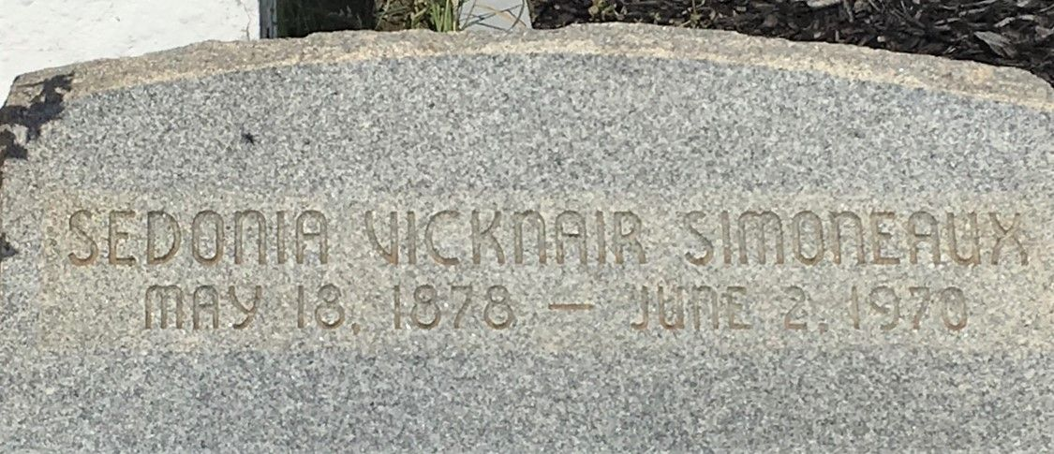
Photo by Team T-Lo

Age 92 years, a native of Reserve, Louisiana, and a resident of Laplace, Louisiana, for the past 40 years.

Wife of the late Felix Simoneaux Sr, and mother of Mrs. Albertine Perilloux, Felix Jr, Frank (Alberick) and Murphy Simoneaux, and Mrs. Eloise Tassin, all of Laplace, Edgar and Melvin Simoneaux of Norco, Louisiana, Mrs. Sidonia Labat of New Orleans, and the late Clarence Simoneaux.

Services were Thursday, 4 Jun 1970 at St Joan of Arc Church, Laplace, with interment in St Peter Cemetery, Reserve.
The Times-Picayune, New Orleans, Louisiana
4 Jun 1970

