Yvonne (Roussel) Simoneaux-Tabb
January 10, 1940 – December 16, 2017

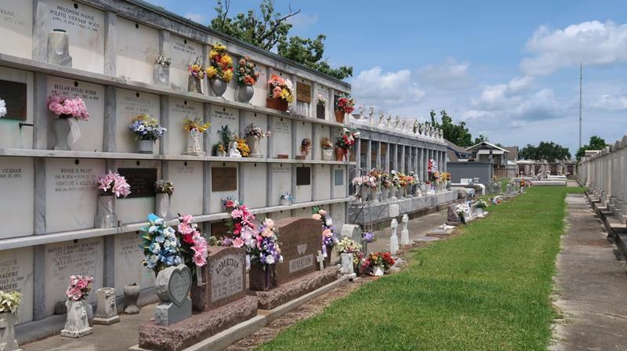

Yvonne R. Tabb, age 77, was born on January 10, 1940 and passed away on December 16, 2017. She was a native and resident of Paulina, LA.
She is survived by children: Sherman (Sandra), Calvin (Tanya), Darryl, Danny (Debbie), Tony (Amanda), Celeste (James), Simona (Blaine), Renette (Kerwick) and numerous grandkids and great-grand kids. She is also survived by two brothers: Norris and Jean Roussel.
She is preceded in death by her parents, Jean “Pim” Roussel, Sr. and Cecile R. Roussel; brothers: Leroy, Felton, Harry “Jumbo”, Freddie Roussel, and James “Billy” Roussel; sisters: Beverly, Verlin, and Elaine Roussel, and Lois Abadie, as well as husbands, Sherman Simoneaux, Sr. and Allen Tabb and sons, Gene and Kelly Simoneaux.
A visitation in her honor will be on Wednesday, December 20, 2017 from 6:00 p.m. until 9:00 p.m. at ROSE LYNN FUNERAL SERVICES, 1870 Cabanose Ave., Lutcher, LA. Visitation will resume on Thursday, December 21, 2017 at St. Joseph Catholic Church in Paulina from 9:00 a.m. until 11:00 a.m. followed by a Mass of Christian Burial. Interment will follow at St. Peter Cemetery in Reserve, LA.

Rose Lynn Funeral Home, Lutcher, Louisiana

