Isabella Mary (Francois) Smith
1934 – January 6, 2023

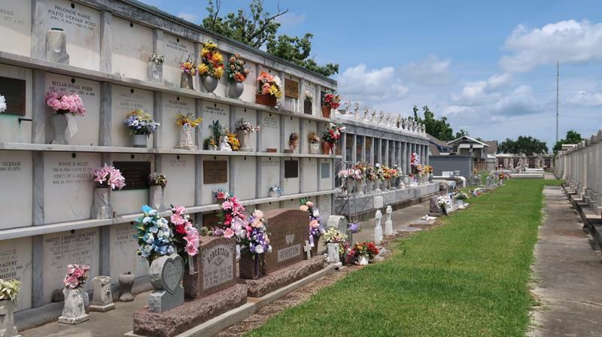

Isabella Mary "Nan" Francois Smith completed her life journey on Friday, January 6, 2023, at her daughter's home in Gonzales, LA at the age of 88. A native of Reserve, LA and a resident of Gonzales, LA.
Beloved wife of the late Alfred Smith. Devoted mother of Charlotte (Allen Jr.) Hooker. Loving grandmother of Krystal and Allen-Michael Hooker.
Daughter of the late Cornelius Francois, Sr. and Isabella Davis Francois. Sister of the late Annabelle Francois, William (Alma) Francois, Cecile Francois (Wallace Jr.) Frank, Cornelius (Aldonia) Francois, Jr., Alfred (Audrey) Francois, Dolores Francois (Gustave Sr.) Howard, Hilton Francois, Catherine Francois White, Ray Francois, and Wilton Francois.
Daughter-in-law of the late Walter Sr. and Evelyn Smith. Sister-in-law of Doris Francois; and the late Ophelia Shepherd, Walter Jr., Lester Sr., Joseph, and Rowena Smith. Also survived by a host of nieces, nephews, other relatives, and friends.
Relatives and friends are invited to attend a Mass of Christian burial on Saturday, January 14, 2023, at 10:00 a.m. at Our Lady of Grace Roman Catholic Church, 780 Highway 44, Reserve, LA. Father Etido Jerome, S.S.J., Celebrant. Visitation at the church at 8:15 a.m. and recitation of the rosary at 9:15 a.m. Entombment to follow at St. Peter Catholic Church Cemetery, Reserve, LA. Final care entrusted to Robottom Mortuary.

The Times-Picayune, New Orleans, Louisiana
January 13, 2023

