James Harlan Smith
March 1, 1932 – January 6, 2007

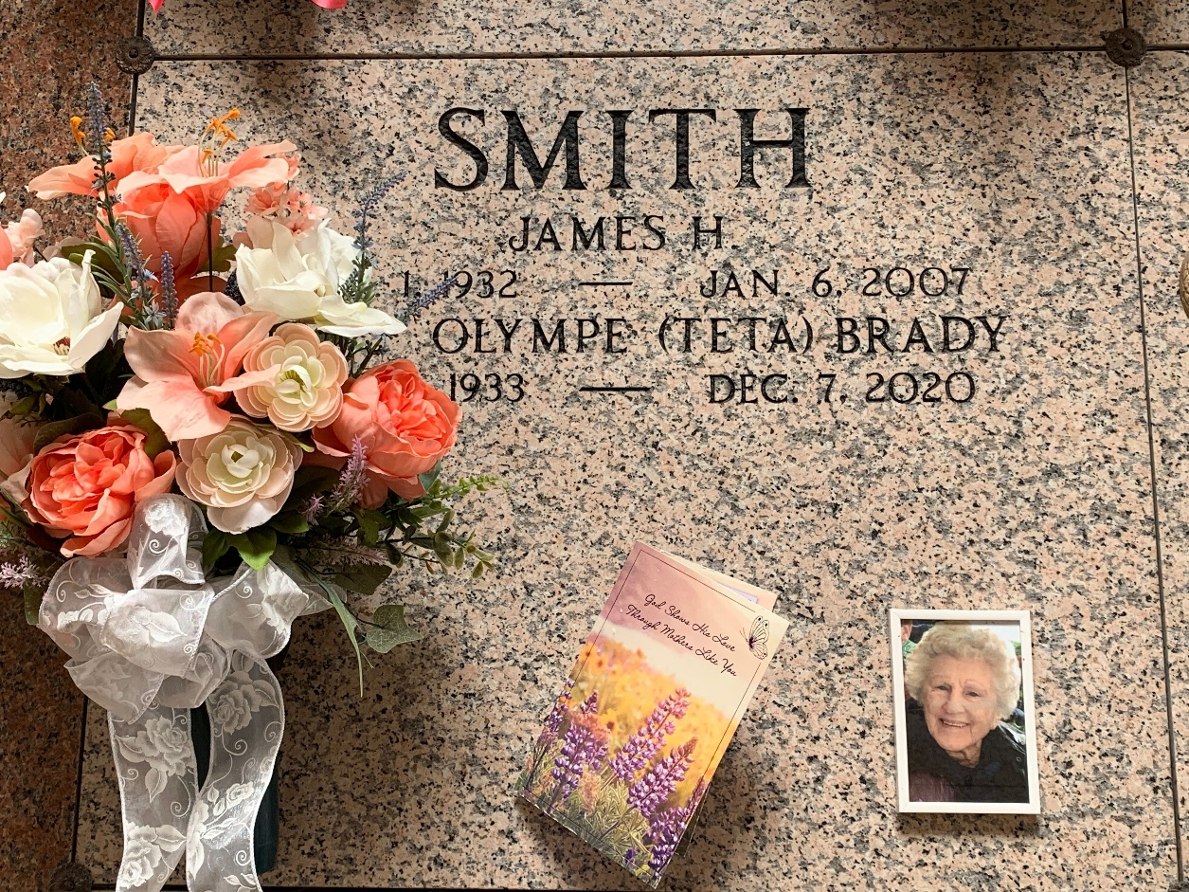
Photo by Team T-Lo

James H. Smith On Saturday, January 6, 2007 At 7:48 Pm.

Beloved Husband Of Olympe (Teta) Blank Smith. Father And Father-In-Law Of Kellie And Wayne Forsythe, Carla Smith And The Late James H. Smith, Jr., Patricia Smith, Sandra And Frank Lovisa And Donna Smith. Grandfather Of Amanda Brown, Austin Forsythe, Scott And Kristi Smith, Cherie, Joey And Jennifer Lovisa. Brother Of Stevenham, Bud Dill And The Late Barbara June
Nelson And Agnes Gay Hawkins. Age 74 Years. A Native Of Oklahoma And A Resident Of Laplace, La. For The Past 13 Years.

The Times-Picayune, New Orleans, Louisiana
January 8, 2007

