James Ronald Smith
March 17, 1946 – May 26, 2016

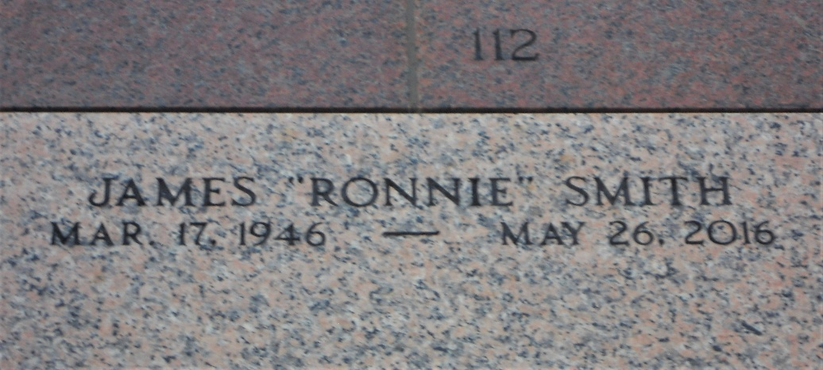
Photo by Team T-Lo

James Ronald ‘Ronnie’ Smith passed away on Thursday, May 26, 2016. He was 70, a native of Bastrop, LA and a resident of Ponchatoula, LA.
Former husband of Joyce Simoneaux Smith. Beloved father of Susan Smith Bourgeois (Kyle) and Frank Smith (Tara). Son of the late Merle Pennington Laws and Shelton Smith. Step-son of James ‘Jimmy’ Laws. Brother of Roger Smith, James ‘Tic’ Laws, Marilyn Smith and the late Alice Smith. Grandfather of Payton Bourgeois, Owen Bourgeois, Seth Borne-Smith, Quinn Smith and Avery Smith.
Relatives and friends are invited to attend the Memorial Mass at Ascension of Our Lord Catholic Church, 1900 Greenwood Dr., LaPlace on Monday, May 30, 2016 at 11:30 a.m. Visitation from 9:30 a.m. until 11:30 a.m.

Millet-Guidry Funeral Home, LaPlace, Louisiana

