Jonathan Anthony Smith
March 30, 1965 – November 10, 2007

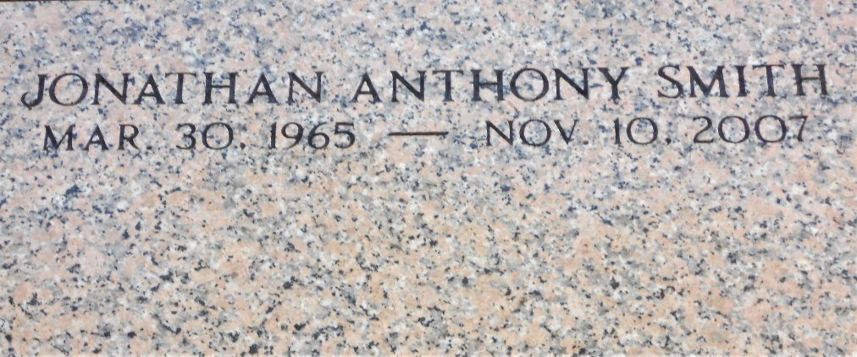
Photo by Team T-Lo

Jonathan Anthony "Silk" Smith, a native of LaPlace and a resident of Gramercy, died Saturday, Nov. 10, 2007, at Cargill Grain Elevator in Reserve. He was 42.
Survived by his parents, Joyce Jones White and Alvin Charles White, of LaPlace; sister, Bonita Thomas; companion, Ramona Collins Ezidore; step-daughter, KenMeisha; two step-sons, QuoVadis and Kendell; four step-grandchildren; an aunt, Marlene Jones; three uncles and their spouses, Donald Jones, Glenn and Johnnie Mae and Julius and Geneva Jones; a mother-in-law, three sisters-in-law, a brother-in-law, cousins, a nephew, other relatives and friends.
The Advocate, Baton Rouge, Louisiana
November 15, 2007

