Olympe (Blank) Smith
September 6, 1933 – December 7, 2020

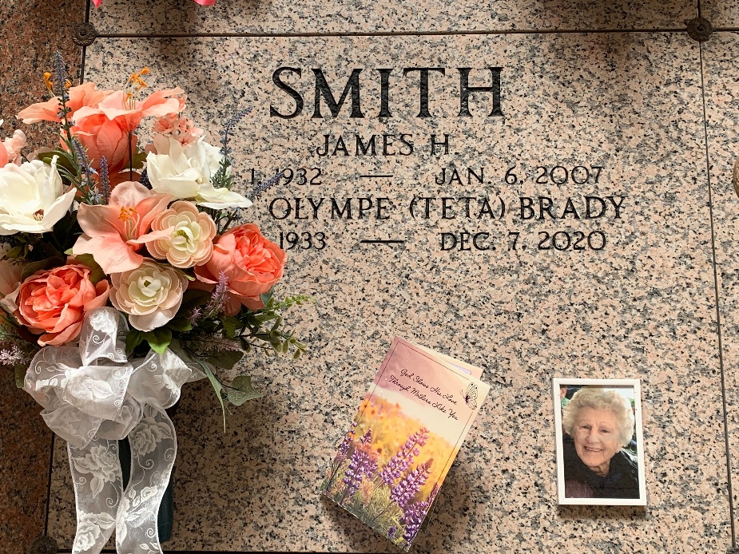
Photo by Team T-Lo

Olympe "Teta" Brady Smith, a resident of LaPlace, passed away peacefully in her daughter's arms on Monday, December 7, 2020 at the age of 87.
She is survived by her daughter, Kellie B. Badeaux and her husband Troy; grandchildren, Amanda Brown (Brandon) and Austin Forsythe; step-grandchildren, Kristi Perilloux (Brian), Scott Smith, Amanda Dottolo (Duffy) and Brandy McGovern (Chris); great-grandchildren, Shelby and Brady Brown, Jaxon & Jake Terrio, Camryn, Kyleigh and Avery McGovern, and Ashton, Adalee and Lucas Dottolo; step-daughter-in-law, Carla Smith; and numerous nieces and nephews.
She is preceded in death by her first husband, Ronald "BUBBY" Brady; second husband, James Smith; parents, Hypolite and Blanche Blank; siblings, Lelia Robertson, Bernard Blank, Marie Loupe, Ferrell Blank, Emelie Eliser and Hypolite Blank.
A visitation will be held on Friday, December 11, 2020 at St. Peter Catholic Church from 9:00 AM until funeral time. A Mass of Christian Burial will take place at 11:00 AM. Interment will follow in the church cemetery.
The family would like to thank Teta's special friends, Dena Gendron, Lindy Lebouef and Ida Brown for their love, care and compassion.
Rose Lynn Funeral Services, Lutcher, Louisiana

