Jack Sterling Snowdy
January 22, 1927 – June 20, 2005

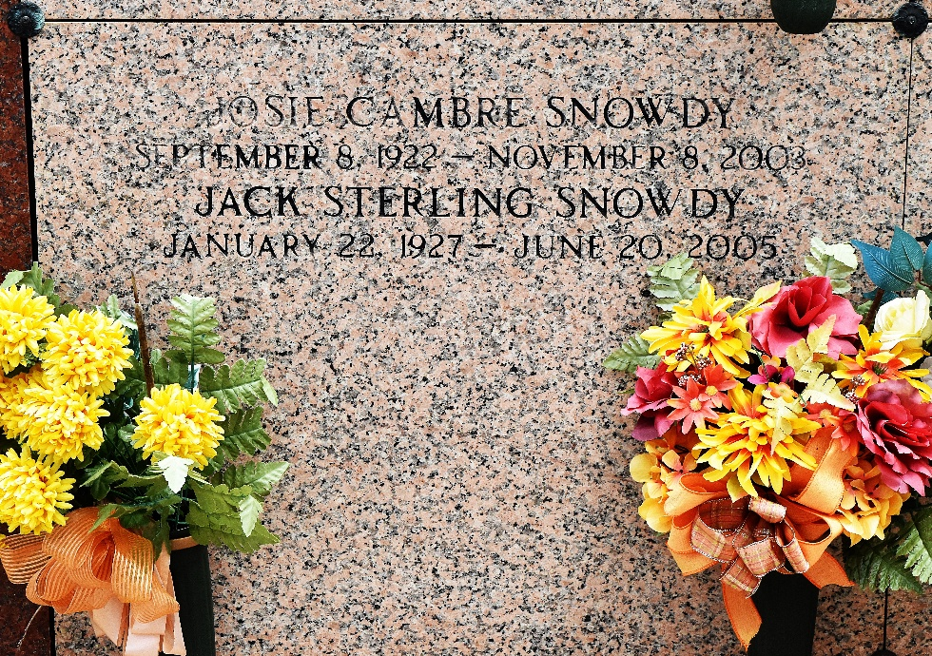

Jack Sterling Snowdy, a retired teacher and longtime arts advocate known to many as the "Father of Fine Arts" in St. John the Baptist Parish, died Monday of congestive heart failure, at East Jefferson Select Specialty Hospital in Metairie. He was 78. Mr. Snowdy was born in Rayville and raised in Olla. He had been a resident of Reserve since 1953.
Survivors include two sons, state District Judge J. Sterling Snowdy of LaPlace and David Snowdy of New Orleans; a brother, Sher S. Creel of Baton Rouge; two sisters, Sylvia D'Angelo and Cecile Lorino of Chandler, Arizona; and two grandchildren.
A funeral will be held Thursday at noon at St. Peter Catholic Church, 1550 River Road, Reserve. Visitation will begin at 9 a.m. Burial will be in the church cemetery. Millet-Guidry Funeral Home is in charge of arrangements.
The Times-Picayune, New Orleans, Louisiana
June 22, 2005

