Josie (Cambre) Snowdy
September 8, 1922 – November 8, 2003

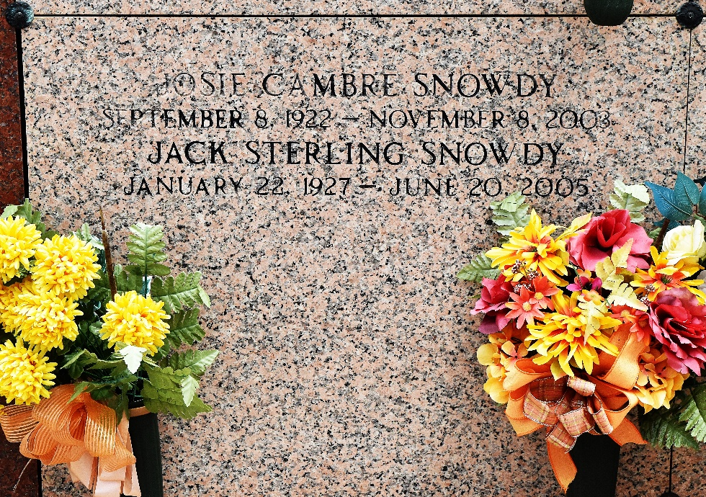

Josie Cambre Snowdy passed away on Saturday 8 Nov 2003. She was a retired French and English teacher at Leon Godchaux High School in Reserve, Louisiana. She was a native and life long resident of Reserve and a graduate of St Mary's Dominican College.
Survivors include her beloved husband, Jack S Snowdy; two sons, David N Snowdy and Judge Sterling Snowdy and daughter-in-law, Hope H Snowdy.
She was preceded in death by two brothers, Ellis and Caliste Cambre, and two sisters, Marie Louise C. Rousselle and Ruth C. Brignac.
Survivors include two sisters, Rita C. Morvant and Aline C. Duhe and 3 brothers, A. Bert Cambre, Lewis W. Cambre, Jr, and Russell Cambre.
Services were Tuesday, 11 Nov 2003 at St Peter Catholic Church, Reserve, with burial in St. Peter Church Cemetery, Reserve.
The Times-Picayune, New Orleans, Louisiana
June 22, 2005

