David Michael Snyder

September 29, 1964 - July 3, 2023

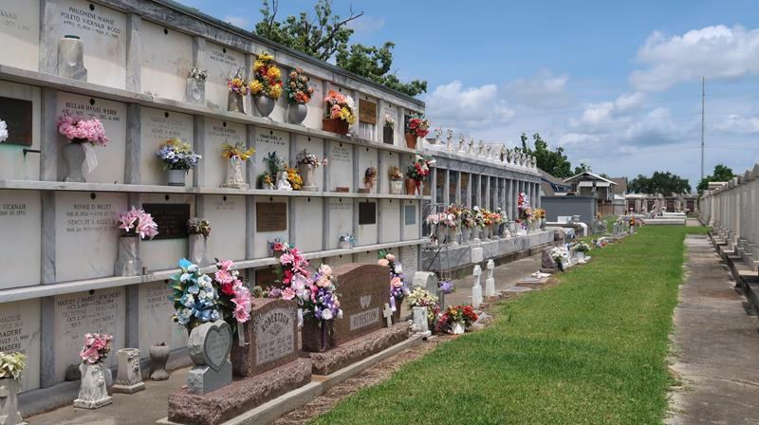

David Michael Snyder, age 58, a resident of LaPlace, LA, passed away peacefully on July 3, 2023.
He was the beloved husband of Patti C. Snyder, and the proud father and father-in-law of Devin M. Snyder (Chelsey) and Courtney S. Istre (Jacob). He was the devoted son of Mary L. Snyder and the late John M. "Sonny" Snyder, Sr. of LaPlace, LA. His loving siblings are Susan S. Ross (Norman III), John M. Snyder, Jr. (Cheryl), and Bridget S. Salzman. He is also preceded in death by his mother-in-law and fathers-in-law, Margaret C. Laurent, Kenneth Laurent, and Calvin J. Catoire. He was also loved by Darrell Catoire (Deborah) and Jan Ladner (Don). His cherished godchildren are Brittany L. Burton, Katie S. Massa, Michael Salzman, and Brady Ross. He was a wonderful uncle and great uncle to many nieces and nephews, whom he loved dearly. A special thank you to his loving nieces, Brandi C. Schnell and Ashley L. Crotty, who cared for him throughout his illness. David retired from Marathon Petroleum Company after 31 years of service.
The family would like to thank Ochsner Hospital Oncology Department, especially Dr. Jonathan Mizrahi, Randi Kihnel, NP and Nakia Brooks, NP, and Notre Dame Hospice Staff, especially Dr. K Zaveri, Lily, Anne Marie, and Pam, for the wonderful care they provided them.
Relatives and friends are invited to attend the Visitation and Funeral Mass on Saturday, July 8, 2023, at St. Joan of Arc Church. Visitation will be held from 10:00 a.m. to 12:00 p.m., with a Funeral Mass at 12:00 p.m. Burial will immediately follow the services at St. Peter Catholic Cemetery.
In lieu of flowers, masses are preferred. Donations in his honor can be made to the Pancreatic Cancer Society.

Millet-Guidry Funeral Home, LaPlace, Louisiana
July 6, 2023

