John Myron Snyder

February 26, 1936 – September 9, 2020

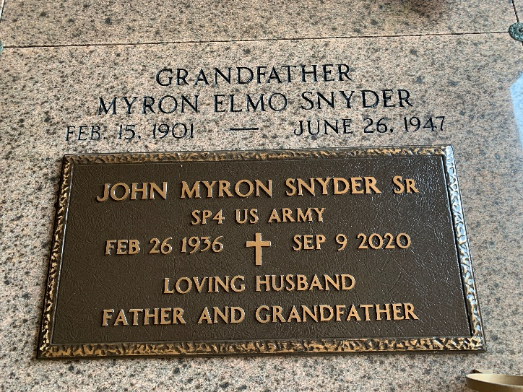
Photo by Team T-Lo

John “Sonny” Myron Snyder, Sr., a life-long resident of LaPlace, passed away peacefully surrounded by his loving wife and family on Wednesday, September 9, 2020 at the age of 84. He proudly served his country in the United States Army.
Sonny was an avid hunter, fisherman, and gardener. He looked forward to playing pitty-pat every Sunday evening with his children and grandchildren. He will be greatly missed by all who knew him.
Upon his return he met the love of his life where they both worked, Mary Lucia Snyder. He was a loving and devoted husband throughout their 61 years of marriage. He is the loving father of Susan S. Ross (Norman), John M. Snyder, Jr. (Cheryl), Bridget S. Salzman, and David M. Snyder (Patti); proud grandfather of Jessica and Brady Ross, Kelly Snyder (Marilyn), Katie S. Massa (Andrew), Hanna S. Ory (Chris), Hailey M. Snyder (fiancé of Ryan Chauvin), Joel and Michael Salzman, and Devin and Courtney Snyder; and caring great-grandfather of Hazel Grace and Maverick Andrew Massa.
Survived by Sister, Sheila S. Spruell (Mike), Brother, Chuckie LeMoine (Donna) & Numerous nieces and nephews.
Preceded in death by Parents, Myron Elmo Snyder and Evelina Snyder LeMoine; stepfather, Linsly LeMoine, Infant grandson, Colby John Ross,
Sister, Betty June Salas & Brother, Gerald Snyder
Relatives and friends are invited to attend his funeral Mass at Ascension of Our Lord Catholic Church, 1900 Greenwood Drive, LaPlace on Monday, September 14, 2020 at 11:00 A.M. Visitation will precede mass beginning at 9:30 A.M. Interment will follow at St. Peter Cemetery, Reserve, LA. Masks will be required.
In lieu of flowers, Masses are preferred.
Rose Lynn Funeral Services, LaPlace, Louisiana
July 6, 2023

