Joseph P. Songy Sr.

January 31, 1928 – December 27, 2024

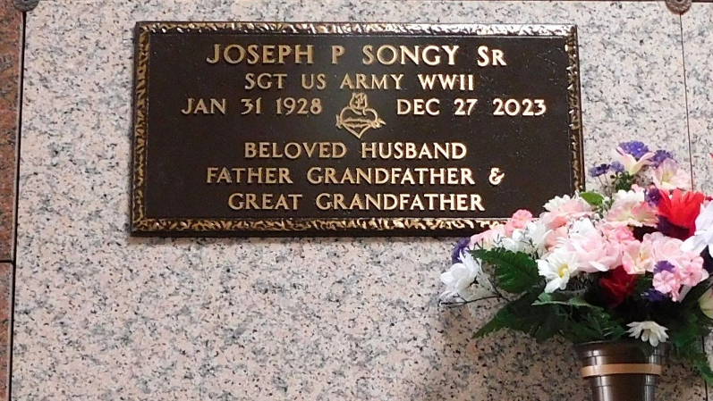
Photos by Mary Agnes Hammett

Joseph "Joe" Pierre Songy, Sr. passed away on Wednesday, December 27, 2023 at his home in LaPlace, at the age of 95.
Beloved husband of Una Songy for 71 years. Loving father of Sonja Springer (Steve), Jona Songy, Joe Songy, Jr. (Julie), and the late Timothy Joseph Songy (Kim). Grandfather of Rhett Emerson (Susan), Ryan Springer (Lauren), David Womax (Stormy), Dayne Womax (Vanessa), Chelsea Tamplain (Adam), Jarett Songy (Nicole), Luke Songy (Misty), and Gabrielle Songy. Great-grandfather of 12 great-grandchildren.
Son of the late Luc Songy and Rosine Waguespack Songy. Brother of the late Luc Songy, Marie Kroll, Guy Songy, Etienne Songy, Jeanne Robert, Bert Songy, Maude Smothers, Ruffin Songy and Katherine Homer. Also survived by numerous nieces, nephews, and cousins.
Joe proudly served in the U.S. Army Post WW2, where he was stationed in Japan during the occupation, and later served in the Korean War. Worked and retired from DuPont in Reserve for 43 years. He loved his family over anything else, in the world. During his free time, he loved fishing, cooking for his family, and gardening, especially raising his tomatoes.
Relatives and friends are invited to attend the Visitation and Funeral Mass on Tuesday, January 2, 2024, at St. Joan of Arc Catholic Church, 529 W. 5th St., Laplace, LA 70068. Visitation from 10:00 a.m. – 11:00 a.m., with a Funeral Mass to follow at 11:00 a.m. A private military burial will take place after the service.

The Times-Picayune, New Orleans, Louisiana
Dec. 30 to Dec. 31, 2023

