Malcolm Michael Songy

October 24, 1942 – August 29, 2024

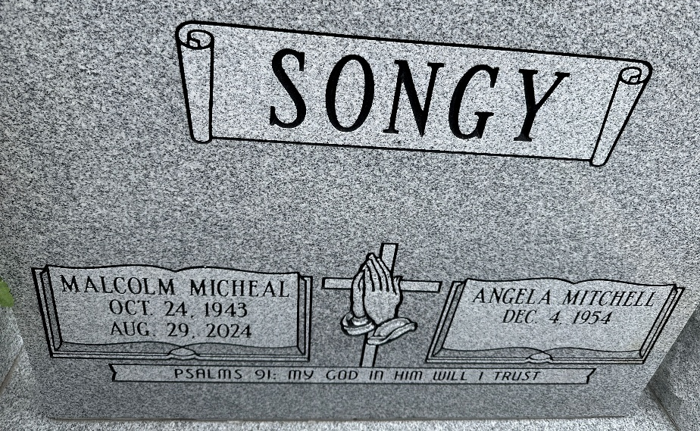
Photo by Team T-Lo

Malcolm Michael "Bob" Songy, born to the parents of Oliver Songy, Sr., and Theresa Barre, to this union Seven Beautiful Children were Loved.
From a young age, Malcolm was raised in the Catholic faith and educated within the St. John Baptist school system. As he grew up, he acquired various skills, including carpentry, cooking, masonry, and mechanics. His final employment was with the River Parish Concrete Company, owned by Rev. Freddie Howard.
Malcolm found the love of his life, Angela Mitchell, and they were united in marriage on March 16, 1991. Through this union, they were blessed with three children. Angela and Malcolm shared a love for dining out and cherished their time together.
In his leisure time, Malcolm enjoyed watching car shows and vintage cowboy shows. He had a passion for restoring old school cars and possessed a green thumb when it came to plants. Known as a Jack of all trades, he earned the nickname "Mr. Fix-It-All" for his remarkable ability to tackle any challenge.
He Leaves to cherish his beloved wife Angela Mitchell Songy of Laplace, LA; two sons Malcolm Turner of San Antonio, Shandon Gordon of Gonzales, LA; one daughter Linda Coleman of Laplace, LA; godchildren; Keiah Keller, Yolanda Caliborne, Twaina Williams, and Trineqa Joesph; eight grandchild-ren; John (Crystal) Pidgeon, Arlisha (Iravis) Guille, Jarvis (Elaina) King, Jevalon (Robin) Pidgeon, Brittany Pidgeon, Jaelon Gordon, Alisa Turner, and Malcolm Turner, Jr. and seven great grandchildren. Devoted nephew, Rev. Eric Keller and devoted niece Andrea Cambre and a host of nieces, nephews, cousins, and friends.
He was preceded in death by his parents, Oliver Songy, Sr. and Theresa Songy, two brothers Oliver Songy, Jr. and Donald Songy, three sisters: Olivia Keller, Loretta Stewart, Eva Duhe, and nephew Edmond Duhe.
A public gathering will be held at Treasures of Life Funeral Services, 315 E. Airline Hwy, Gramercy, LA 70052 on Friday, September 6, 2024, from 3-5pm. A Celebration of Life and Legacy will be held on Saturday, September 7, 2024, at New Wine Christian Fellowship Center, 1929 W. Airline Hwy, Laplace, LA 70068. Visitation begins for 8am, service begins for 9:30am. Interment St. Peter Catholic Church cemetery.

Treasures of Life Funeral Services, Gramercy, Louisiana

