Palmyre (Hymel) Songy

July 16, 1882 – October 1, 1955

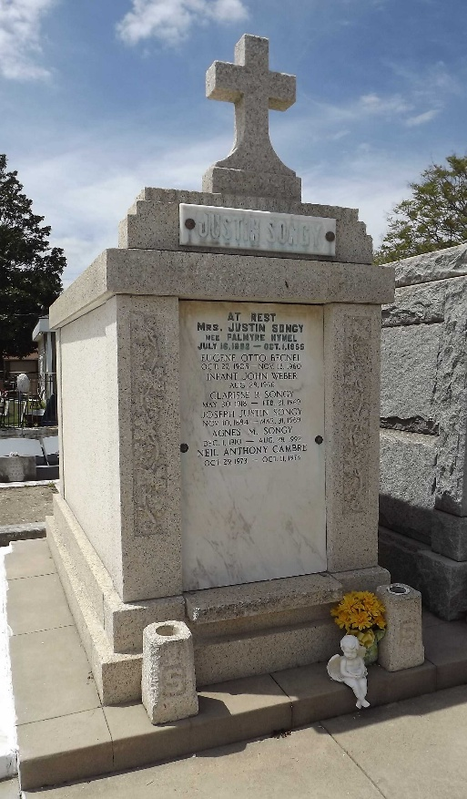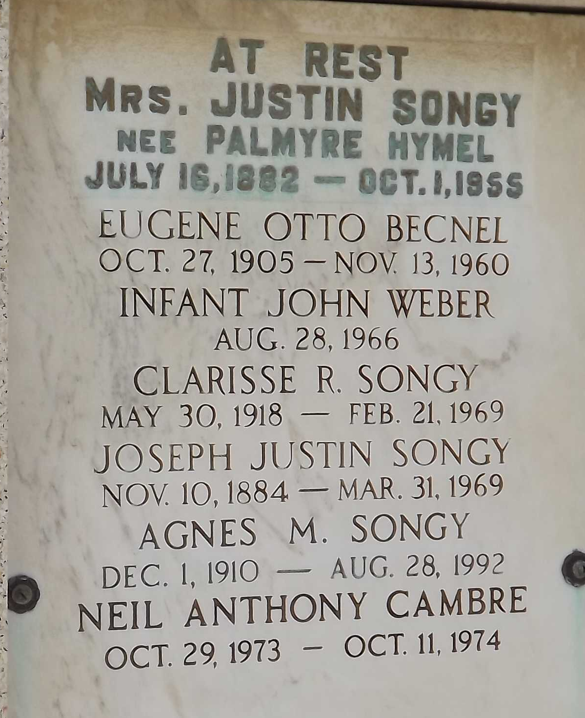
Photos by Mary Agnes Hammett

Palmyre Hymel, wife of Justin Songy, Saturday, 1 Oct 1855 at her residence in Reserve, LA.

Mother of Mrs. E. J. Curren of Houston, TX, Mrs. Otto Becnel of New Orleans, LA, and Mrs. Francois Cambre Jr, Mrs. Norman Weber, Edmond, Agnes and Clarisse Songy of Reserve, LA.

She was age 73 years, a native of Vacherie, LA, and a resident of Reserve for the past 25 years. Interment in St Peter Cemetery, Reserve, LA.

The Times-Picayune, New Orleans, Louisiana
October 3, 1955, p. 2

