Una Marie (Faucheux) Songy

March 16, 1934 – January 15, 2025

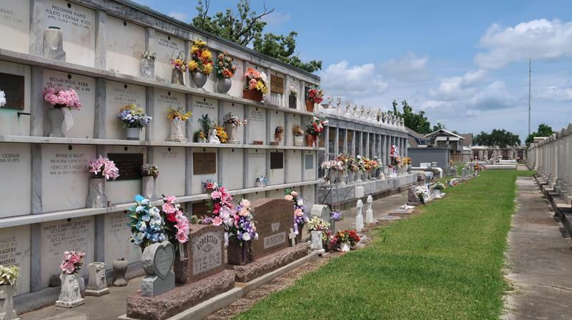

Una Songy, a resident of LaPlace, LA passed away on Wednesday, January 15, 2025, at the age of 90.
Beloved wife of the late Joe Songy, Sr. for 72 years. Loving mother of Sonja Springer (Steve), Jona Songy, Joe Songy, Jr. (Julie), and the late Timothy Joseph Songy (Kim). Grandmother of Rhett Emerson (Susan), Ryan Springer (Lauren), David Womax (Stormy), Dayne Womax (Vanessa), Chelsea Tamplain (Adam), Jarett Songy (Nicole), Luke Songy (Misty), and Gabrielle Songy. Great-grandmother of 12 great-grandchildren. Daughter of the late Leopold Faucheux and Octavia Zeringue Faucheux. Sister of the late Lelia Tregre (Urbin), Aurore Verdin (Ed), Edgar Faucheux (Audrey), Therese Zeringue (William), Clancy Faucheux (Una Fay), Adline Keller (Ernest), and Daniel Faucheux (Dolores). Also survived by numerous nieces, nephews, and cousins.
Una had a strong Catholic faith; she was especially devoted to The Virgin Mother and St. Michael. She enjoyed cheering for the Saints and LSU, as well as the peaceful activity of bird watching. She took pride in her garden. Above all her greatest joy in life was rocking and kissing her grandchildren and great-grandchildren, who were the light of her life.
Relatives and friends are invited to attend the Visitation and Funeral Mass on Friday, January 24, 2025, at St. Joan of Arc Catholic Church, 529 W 5th St, Laplace, LA 70068. Visitation from 10:00 a.m. – 12:00 p.m., with a Funeral Mass to follow at 12:00 p.m.

Millet-Guidry Funeral Home, LaPlace, Louisiana

