Barney “B. B.” Spears Jr.

January 12, 1936 – November 11, 2008

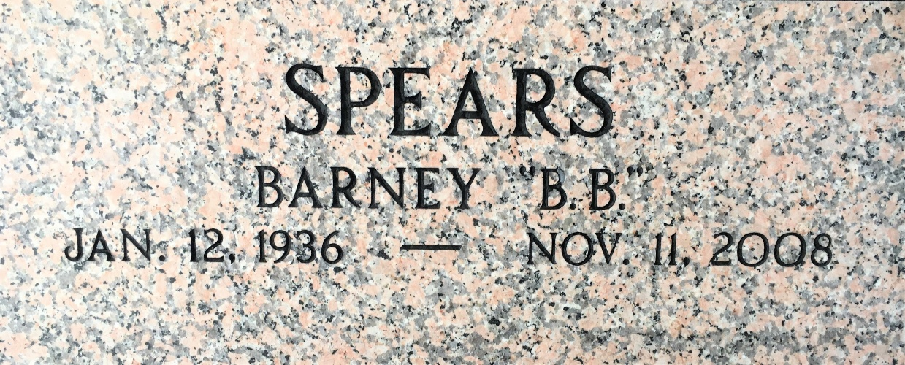
Photo by Team T-Lo

Barney 'B.B.' Spears, Jr., departed this life on Tuesday, November 11, 2008.

He leaves to cherish his precious memories: 1 daughter, Kenyetta R. Spears of Fairfax, VA.; 3 sons: Barney Spears III of La Place, LA, Gerald Spears of New Orleans, LA, and Kendall Bazile of Baton Rouge, LA.; 8 grandchildren, a host of nieces, nephews, other relatives and friends.
He was preceded in death by his parents, Gertrude H. and Barney Spears, Sr.; and 1 brother, Calvin Spears.

The Times-Picayune, New Orleans, Louisiana
November 17, 2008

