Carolyn (Boutwell) St. Amant
November 17, 1933 – September 21, 2005

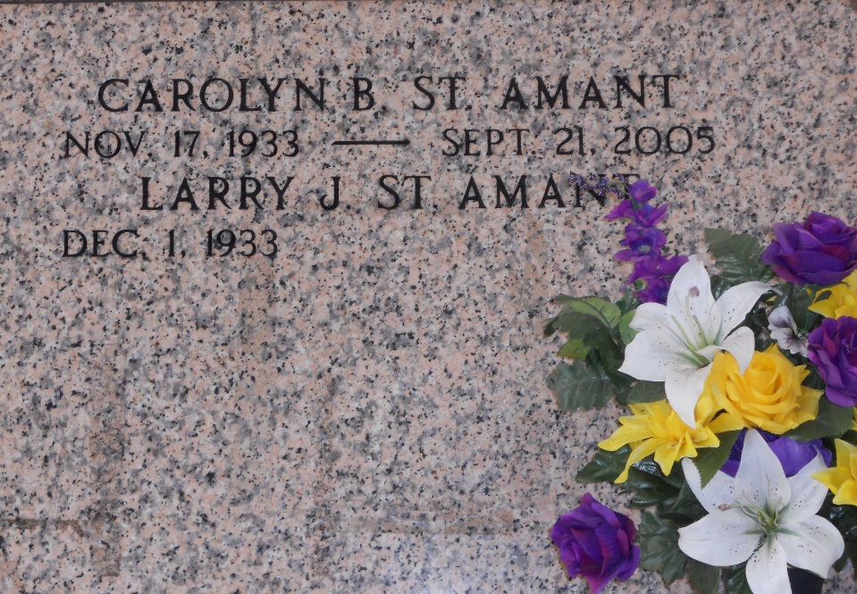
Photo by Team T-Lo

Funeral services for Mrs. Carolyn Boutwell St. Amant, 71 of Reserve, LA will be held at St. Peter Catholic Church in Reserve, LA. on Tuesday, September 27, 2005 at 11:45 AM. Interment will follow at St. Peter Cemetery under the direction of Millet-Guidry Funeral Home in LaPlace, LA.
Mrs. St. Amant was born on November 7, 1933 and passed away Wednes-day, September 21, 2005 at home. She was a resident of Reserve, LA, a retired school teacher, and a member of St. Peter Catholic Church.
Survivors include her husband Larry St. Amant of Reserve, LA four sons; Mark, Kevin, Craig, and Kent St. Amant all of Reserve, LA; two brothers Billy Boutwell of Winnsboro and Don Boutwell of Kingwood, TX; one sister Beverly Matherne of Norco, LA; and six grandchildren.
The family will receive friends at the funeral home from 9:00 AM to 11:45 AM Tuesday, September 27, 2005.
The News-Star, Monroe, Louisiana
Sunday, September 25, 2005

